Annex 3
to the Final Implementation Report

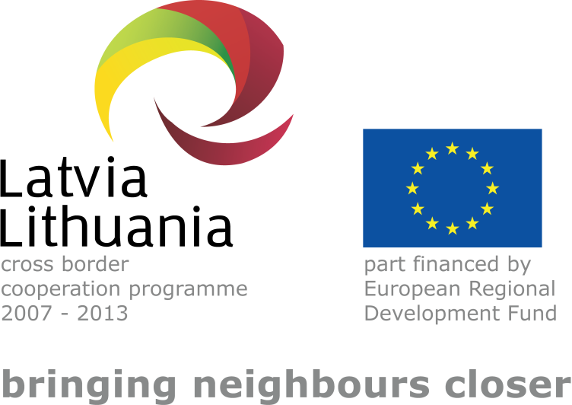

Latvia–Lithuania Cross Border Cooperation Programme 2007–2013
SUMMARY
FINAL IMPLEMENTATION REPORT

- The summary is compiled as a reply to the request of DG Regio to the ETC Programme Managing Authorities. The summary focuses on the areas of cooperation where the Latvia – Lithuania Programme 2007 – 2013 brought the changes, including main achievements and beneficiaries.

2017

What has the Programme achieved?
A clear impact on the better environmental conditions in the Programme area, people’s well-being, capacity and also security, and cultural co-operation are the main benefits from the 129 funded projects implemented by 538 partners with total spent funding EUR 68 559 316,13.
The projects in the field of education/human resource management were focused on ensuring the obtainment of skills necessary in the labour market through common educational infrastructure, as well as harmonised and international study programmes. There was strong cooperation element in these projects as the partner organisations were jointly working to harmonise the educational programmes according to the modern standards and labour market requirements, train and educate 1268 persons in total with the Programme support, involve 174 teachers in cross border experience exchange and education activities and improve 28 educational buildings.
There are significant achievements in the joint management of public services and natural resources. Projects in these fields were characterised by large partnerships to cover wide area in the Programme territory. Main achievements are related both to the development of policy planning (for example, harmonising water policy and activities to achieve better water status at cross-border level in compliance to Environmental Standards Directive) and infrastructure (for example, development of the infrastructure necessary for the management and protection of nature resources in order to prevent possible threats and improve accessibility). During the Programme the conditions of 70 places along rivers and lakes were improved and 12 awareness-raising campaigns organised.
In the sphere of business promotion 6102 people improved their skills and knowledge to compete in labour market, 3700 persons received business consultations, 21 networks for business and research were created and 18 business sites were upgraded with business support infrastructure.
Transport and accessibility area benefited from the Programme by 14,7 km of renovated bicycle trails, reconstructed 29 roadside rest areas, improved 5 harbour communication systems and educated 3000 children on road safety.
The Programme highlighted the importance of the use of innovative methods and know-how in health and social care services which translated in the Programme achievements – for example, created favourable conditions for the provision of social rehabilitation for the mentally disabled in the regions.
Implemented projects have produced results and established structures which exist beyond the lifetime of projects. In that sense the Programme funding has served as a start-up financing towards durable and sustainable solutions that are maintained by the projects after their end and sometimes also developed further in new projects.
Who has benefitted?
The biggest beneficiaries have been the project partners, the participants in the project events, the people to whom the projects were targeted like entrepreneurs, tourism service providers, and different organisations dealing with natural environment management, human resource management, education, R&T development and business support/promotion.
In overall, the benefits from the Programme are daily felt by 3 million people in the Programme area of 80 160 km², (approximately 64% of both countries) with 588 km of common border.
Where does the evidence come from?
Information was collected from the final Progress Reports, day-to-day monitoring and communication with the projects, taking into account that Programme specifically requests to report on the durability and impact of the projects when submitting the final Progress Reports. Moreover, the results of the Programme Thematic Capitalisation Reports done in 2014 and the Programme evaluation carried out in 2011 were used.

