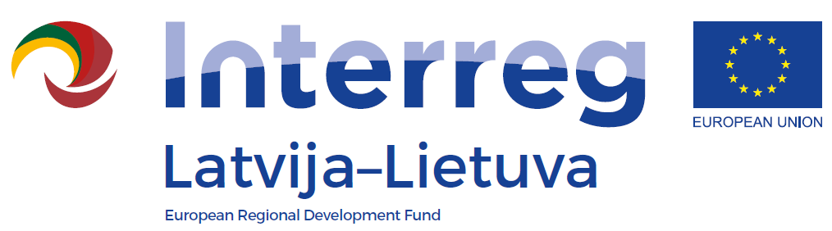
Information seminar
1st Call of the INTERREG V-A
Latvia-Lithuania Programme 2014-2020

AGENDA
18 May 2016
Place and venue: Jelgava District Council, 1st floor seminar room, Pasta street 37, Jelgava

9:30 – 10:00 | Arrival and registration
10:00 – 10:05 | Welcoming
10:05 – 10:45 | Overall information on Programme:  - selected Thematic Objectives and Investment Priorities  - possible supported activities  - requirements for projects  - information on assessment criteria and assessment procedures  - information and communication requirements  Questions and answers
10:45 – 11:15 | Financial management:  - eligibility of costs  - planning of the project budget  Questions and answers
11:15 – 11:40 | Coffee/Tea break
11:40 – 13:10 | Preparation and submission of the application form in the electronic Monitoring System  Questions and answers
13:10 – 14:00 | Individual consultations

- The seminar is organised by the Joint Secretariat of the Interreg V-A Latvia – Lithuania Programme 2014-2020.
- Seminar language – English.
- Participation is free of charge.

