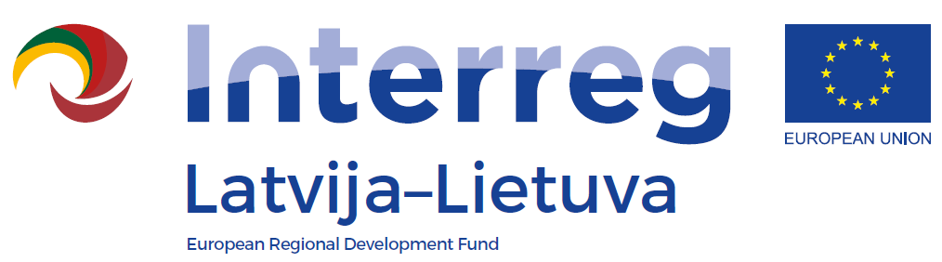
Information seminar
1st Call of the INTERREG V-A
Latvia-Lithuania Programme 2014-2020

AGENDA
31 May 2016
Place and venue: Kuldiga Art Gallery, seminar room, 1905. gada street 6, Kuldīga

10:30 – 11:00 | Arrival and registration
11:00 – 11:05 | Welcoming
11:05 – 11:45 | Overall information on Programme:  - selected Thematic Objectives and Investment Priorities  - possible supported activities  - requirements for projects  - information on assessment criteria and assessment procedures  - information and communication requirements  Questions and answers
11:45 – 12:15 | Financial management:  - eligibility of costs  - planning of the project budget  Questions and answers
12:15 – 12:40 | Coffee/Tea break
12:40 – 14:10 | Preparation and submission of the application form in the electronic Monitoring System  Questions and answers
14:10 – 15:00 | Individual consultations

- The seminar is organised by The seminar is organised by the Joint Secretariat of the Interreg V-A Latvia – Lithuania Programme 2014-2020.
- Seminar language – English.
- Participation is free of charge.

