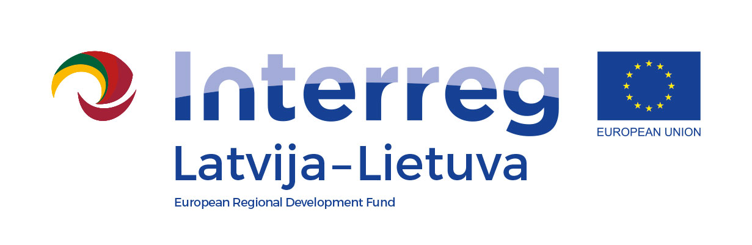

Project Partner Declaration

Project title
Project acronym
Project number
In the event of selection of the above mentioned project for funding from Interreg V-A Latvia–Lithuania Programme 2014–2020, I, the undersigned, as the authorised representative of the organisation listed below, hereby certify that:

- The legal status and legal address or permanent location of our organisation complies with the eligibility rules set in the Programme manual;
- No expenditure related to the above mentioned project has been, is or will be funded by any other EU programme or other financial instruments;
- We are familiar with the content of the application and we understand what our role in the project will be;
- We possess sufficient human, financial and administrative capacity to implement project activities. In particular we will be able to maintain sufficient financial liquidity to pre-finance project activities;
- We commit ourselves in doing everything in our responsibility to foster successful implementation of the project according to the project work plan and achievement of project main outputs as stated in the application;
- We will follow the principle of cooperation, use of the project’s resources in line with the principles of economy, efficiency, effectiveness and impartiality and the national, Programme and European Union legislation;
- We have read the Programme document and the Programme manual and understood what our respective obligations are. We authorise the Lead partner to conclude the Subsidy contract with the Managing Authority, and represent us in all matters with the Managing Authority regarding the project implementation. Furthermore we are aware that we will have to conclude partnership agreement with the Lead partner as required in the Programme manual;
- We are aware of our obligation to inform the public about funding obtained from the Programme and we will comply with information and communication requirements set in the Programme manual;
- We will undertake all necessary precautions to avoid situations leading to possible conflict of interest and corruption by following all relevant national laws and regulations;
- The total eligible budget of our organisation within the project is EUR <insert amount>. We hereby declare to participate in the project as project partner and to provide EUR <insert amount> as co-financing;
- We will provide financing to cover all non-eligible expenditure which might occur during project implementation;

Official title of the organisation in English
Official title of the organisation in national language
Legal address
Registration number
Name of the authorised representative
Position
Signature
Date of signature

This form must be completed by project partner organisation, and uploaded to eMS.

