O.T1.1 Latvian and Lithuanian law enforcement authorities and 4 municipalities participated at the capacity building activities
In the result of the project planned number of institutions, participating in cooperation are 8: 4 Latvian and Lithuanian police and border guards and 4 local municipalities.
All planned activities in order to achieve the main output O.T1.1. have been implemented:
Activity | Description
4 Thematic security meetings organized | - Thematic meeting on illegal migration organized in Kraslava Municipality, LV, April 24-25, 2018 in order to create and strengthen the synergy platform for the civil security of Eastern Latvia and Lithuanian border area.  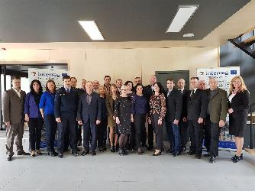  - Thematic meeting on use on the newest technologies for the Law Enforcement Authorities, innovations at the state security, police work, border safety. Searching an information and checking the Internet, testing of computer systems, mobile devises etc. Data analysis. Problems of criminal procedural laws connected with use of information technologies.organized in Kraslava Municipality, LV, May 24-25, 2018.  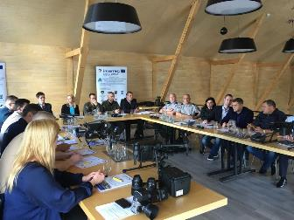  - Thematic meeting on the Fight against smuggling and illegal movement of excize goods organized in Moletai district, Utena region, Lithuania, November 22-23, 2018.  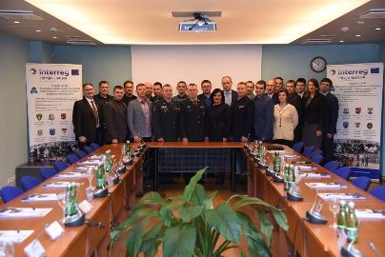  - Thematic meeting on the challenges in combating cybercrime and terrorism organized in Anykščiai district, Utena region, Lithuania, March 28-29, 2019.  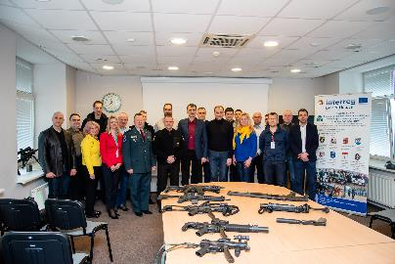
1 Study tour organized | The study tour to Netherlands and Germany was organized (10 PARTICIPANTS, 5 DAYS) at May 7-11, 2018 - order to increase the competencies for officials and employees work of law enforcement institutions and increasing the awareness for cooperation between citizens, municipalities and law enforcement authorities. There we several visits and discussions organized in: Embassy of the Republic of Lithuania to the Kingdom of the Netherlands; Europol, production/ distribution company of video surveillance systems MOBO-TIX AG; Kaiserlautern police department etc.  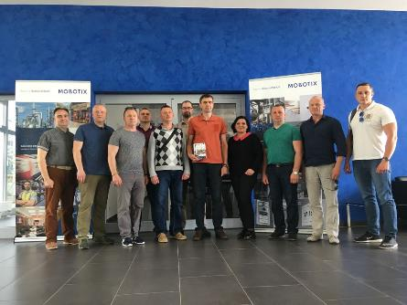
1 Experience exchange tour organized | Experience exchange tour organized in Visaginas and Šauliai in LT, Daugavpils and Jelgava in LV, March 14-16, 2018 - (20 attendants, 3 days) in order to visit municipalities and video surveillance centers, discuss the data analysis of video surveillance systems and use of data in order to combat the cross-border crime and improve the civil security and introduce with different methods of cooperation between citizens, municipalities and law enforcement authorities.  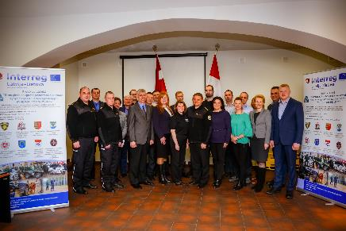
1 Capacity building event organized | In order to increase the capacity for Latvian and Eastern Lithuanian law enforcement authorities, to introduce with practical, theoretical and technological initiatives and possibilities, that could reduce workload and make police and border guard job more efficient, 3 days Capacity building event has been organized by PP5 in Utena, LT, October 16-18, 2017.  The participation of all project partners has been provided, in total 48 participants. Planned topics presented and discussed. he Plan for emergency response has been finalized at the end of 3 days Capacity building event. Evaluation of the event organized and summarized. In total 45 questionnaires haves been summarized.  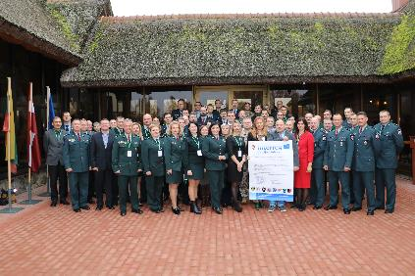
1 Final conference organized | Final Conference organized in Silene, Daugavpils municipality, December 12-13, 2019. in order to finalize the project results.  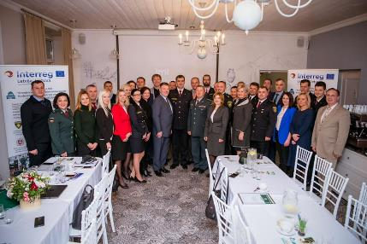  Benefits or the project defined by partners  1) Trained staff of law enforcement institutions;  2) Children involved into the safety campaigns, visits in schools organized, public awareness on the public security and traffic safety increased;  3) International partnership within law anforcement institutions and municipalities;  4) Established cross boder network within staff of police and border guar service on both sides of the border in Latvia and Lithuania, including change or e-mail and phone contacts, as well as not – offialial communication;  5) Intelligent video surveillance platform with transport identity recognition software established;  6) Cross border co-operation Plan for emergency response has been elaborated for the operational involvement in fire-fighting, rescue of persons, solving not standart situations with specific language speking people, murdering etc.;  7) The thematic meeting on the threats of cybersecurity and cybercrime has initiated the reasons for future cross border co-operation;  8) In the result of project involved municipalities have increased their capacity and established international cooperation network for the public security;  9) Acquired equipment have contributed into the prevention and public security issues;  10) The implemented project have increased capacities and experience of the involved project staff ;  11) In the result of the implemented security campaign "Look and speak!", the public awareness of dealing with non-standard situations in the face of border crime is improved / enhanced;  12) During the study visit to Germany and the Netherlands, invaluable experience has been gained in using the video surveillance system in other EU countries for public safety and law enforcement purposes. Stable contacts established with Europol officer and insight into Europol's work gained.

Partners and participants were interested and were active into the cooperation and participation at the events. Is was positively impacted the project target groups – general public, municipalities and law anforcement institutions. The capacity for Latvian and Eastern Lithuanian law enforcement authorities were increased, introduction with practical, theoretical and technological initiatives and possibilities impacted the reducement of workload and made police and border guard job more efficient.
The thematic meeting on the threats of cybersecurity and cybercrime has initiated the reasons for future cross border co-operation between Latvian and Lithuanian law enforcement institutions, not only police and border guards, but also military structures and rescue services;
The implemented project has increased capacities and experience of the involved project staff. The improved capacities of the Latvian and Lithuanian police and Border guard will strengthen the human resources of the respective organizations, cooperating across the border within its existing institutional structure and budget. It should ensure continuity and lasting effect beyond the project duration.
During the study visit to Germany and the Netherlands, invaluable experience has been gained in using the video surveillance system in other EU countries for public safety and law enforcement purposes. Stable contacts established with Europol officer and insight into Europol's work gained.
In the result of the implemented security campaign "Look and speak!", the public awareness of dealing with non-standard situations in the face of border crime is improved / enhanced.

