O.T2.2 Intelligent video surveillance platform with transport identity recognition software
Intelligent video surveillance platform with transport identity recognition software created on both sides of the border Latvia and Eastern Lithuania by installation the intellectual night and day video surveillance systems with state vehicle registration number recognition on all international routes and domestic transit routes in Latvian and Lithuania Eastern border territories: 17 cameras on LV territory, 26 cameras in LT.
LP, State police of Latvia
Title | Picture
Mobile device/ Mobilā ierīce (trauksmes) darbībām ar sistēmu un sistēmas uzraudzībai
Video surveillance camera and accessories/ Videokamera IP ar piederumiem, 17 pcs. | 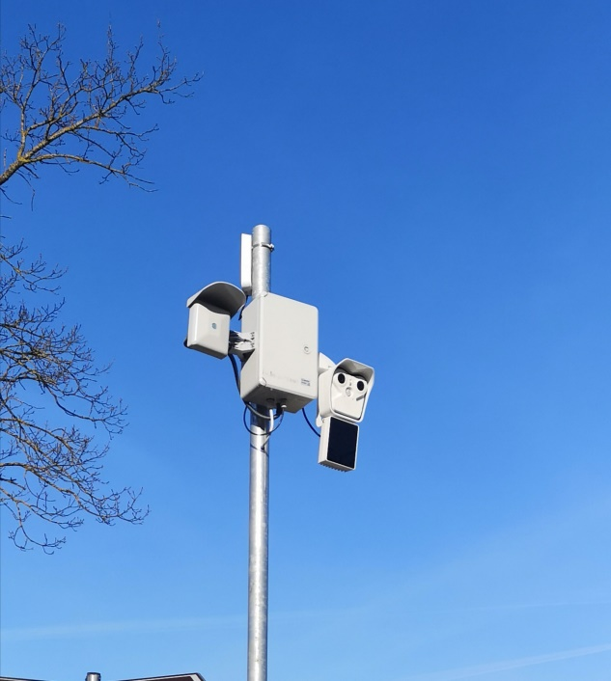
Uninterruptible power supply / Nepārtrauktās barošanas bloks, 2pcs. | 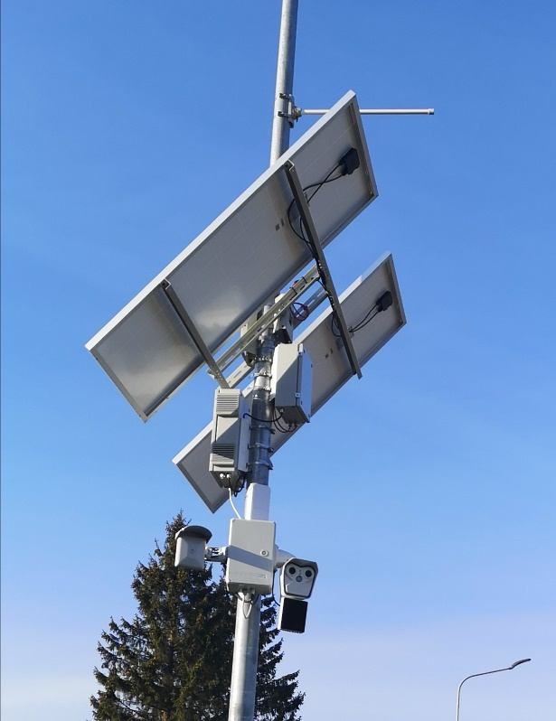
Transport identity recognition soft and systeem server/ Sistēmas serveris ar ANPR programmatūru

PP5 Police, Lithuania
-Attached in pdf format.-
The general public of the mentioned areas by the achieved main project outputs: Latvian and Lithuanian law enforcement authorities and 4 municipalities participated at the capacity building activities; Cross border network for the public security; Intelligent video surveillance platform with transport identity recognition software; Intelligent video surveillance systems for public security; Improvement of material bases, will benefit by the following:
- Visitors and the inhabitants of the project target area will have not only sense of security, but also really more safety area;
- As the locations of acquired video surveillance cameras is limited access information, it is challenge for existing and potential crimes to cross the borders criminally;
- As the Intelligent video surveillance platform with transport identity recognition software and Intelligent video surveillance systems for public security are used not only for monitoring the cross border crime but also used (with real results at this moment) for the public safety, the general public is more trust the capabilities of law enforcement institutions.

