O.T2.3 Intelligent video surveillance systems for public security
Intelligent video surveillance systems for public security installed in Kraslava, Karsava, LV and Utena, Moletai, LT:
PP3, Kraslava, LV: 10 video surveillance cameras and 1 mobile video surveillance set;
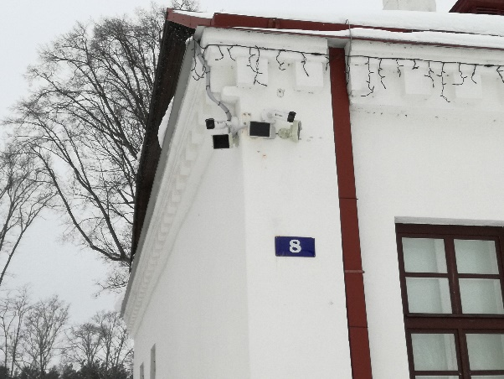
PP4, Karsava, LV: 8 video surveillance cameras with installations;
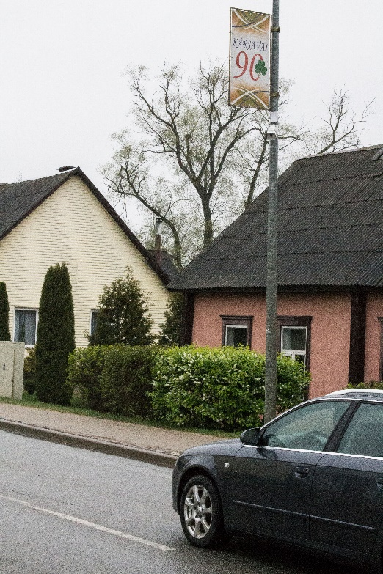
PP6, Utena, LT: 1 mobile video surveillance camera, 1 thermal binocular and 12 video surveillance cameras with installations;
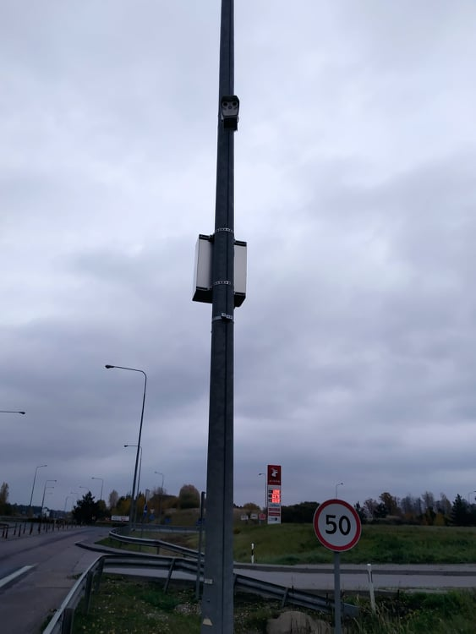
PP7, Moletai, LT: 6 video surveillance cameras with installations.
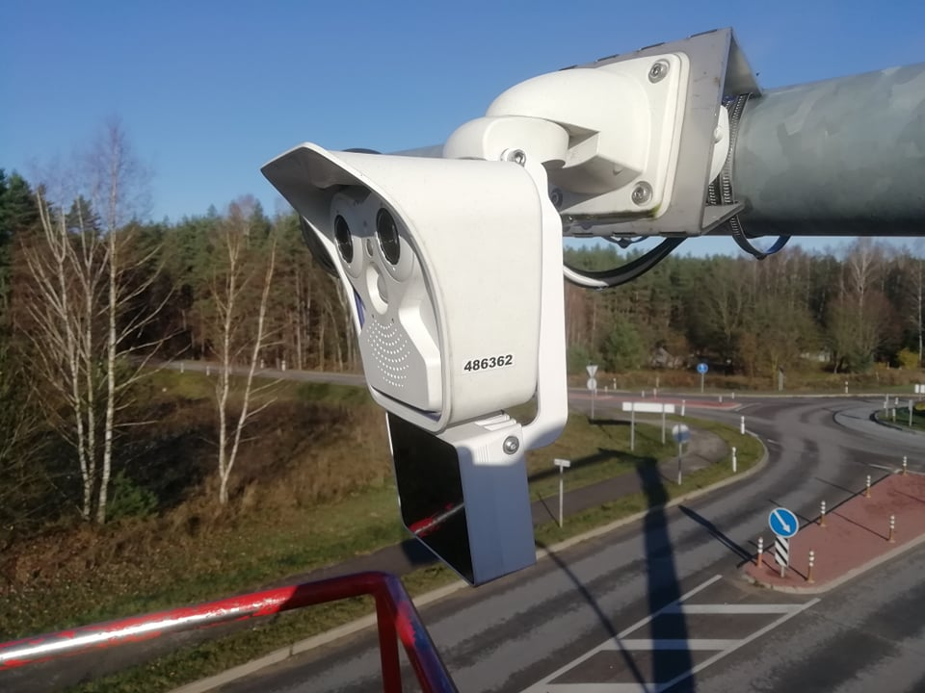
Children involved into the safety campaigns, visits in schools organized, public awareness on the public security and traffic safety increased.
RPI-During the visit in Medumi school, Latvia the main issues on safety issues were presented, demonstrations of dogs and the promotion of the profession of border guard ensured. Utena police officers organizated 4 meetings on LT side in kindergartens and in the classroom of road safety. The meetings have been taught about safe behaviour on the road. Ignalina border guard unit have organized 1 meeting with students on "road safety". In total 6 meetings organized.
RPII-PP2: Organized 1 visit of representatives of the State Border Guard of the Republic of Latvia in Medumi school on March, 2018. PP5 has organized 3 visits with local public of the safety issues: 2018-01-27 in Utena county was traditional winter rally "Winter Rally-2018". 2018-02-10 in Dusetos republican trotters racing on ice "Sartai - 2018". Reflectors and other representative items was shared by offiers from Lithuania and Latvia in the events. Society could feel safe. 2018-03-14 at Aukštakalnis school in Utena was presented project and Security campaign "Look and speak!" about Safe in road.
RPIV - 7 visits has been organized to the schools located near the border on October 15, 2019 by Latvia Border guard representatives (Saskanas preliminary school, Daugavpils), November 5, 2019 by Latvia Border guard representatives (Silene school), November 11, 2019 by Latvia Border guard representatives (Krievu licejs, Daugavpils) and November 11, 2019 by Latvia Border guard and police representatives (Indra and Robežnieki schools, Kraslava Municipality), February 12, 2020 by Latvia Border guard representatives in Daugavpils Border Guard administration within the "shadow Day", November 13, 201 (Daugavpils pilsētas bērnu un jauniešu centrs Kauniba kopā ar zemessardze). The cynologists with their dogs has participated almoust at all meeting to incrase the atractiveness on the visits and creating interes for children on the border guar work and safety issues. (For preliminary 50 children each).
The general public of the mentioned areas by the achieved main project outputs: Latvian and Lithuanian law enforcement authorities and 4 municipalities participated at the capacity building activities; Cross border network for the public security; Intelligent video surveillance platform with transport identity recognition software; Intelligent video surveillance systems for public security; Improvement of material bases, will benefit by the following:
- Visitors and the inhabitants of the project target area will have not only sense of security, but also really more safety area;
- As the locations of acquired video surveillance cameras is limited access information, it is challenge for existing and potential crimes to cross the borders criminally;
- As the Intelligent video surveillance platform with transport identity recognition software and Intelligent video surveillance systems for public security are used not only for monitoring the cross border crime but also used (with real results at this moment) for the public safety, the general public is more trust the capabilities of law enforcement institutions.

