O.T2.4 Improvement of material bases
Material bases improved for 4 Latvian and Lithuanian law enforcement authorities: police and border guard in order to to combat the cross-border crime:
- Lead Partner, State Police of Latvia acquired 3 Thermal Imaging Cameras, 5 Night Vision Monoculars, 6 SnapShot cameras and 1 mobile device;
Title | Picture
Thermal Imaging Camera / Termokamera Pulsar Helion XP50 | 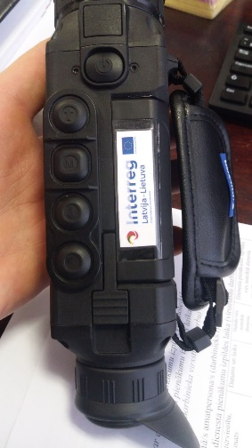
Night Vision Monocular / Nakts redzamības monoklis Challenger G2+3.5x56 NV Scope | 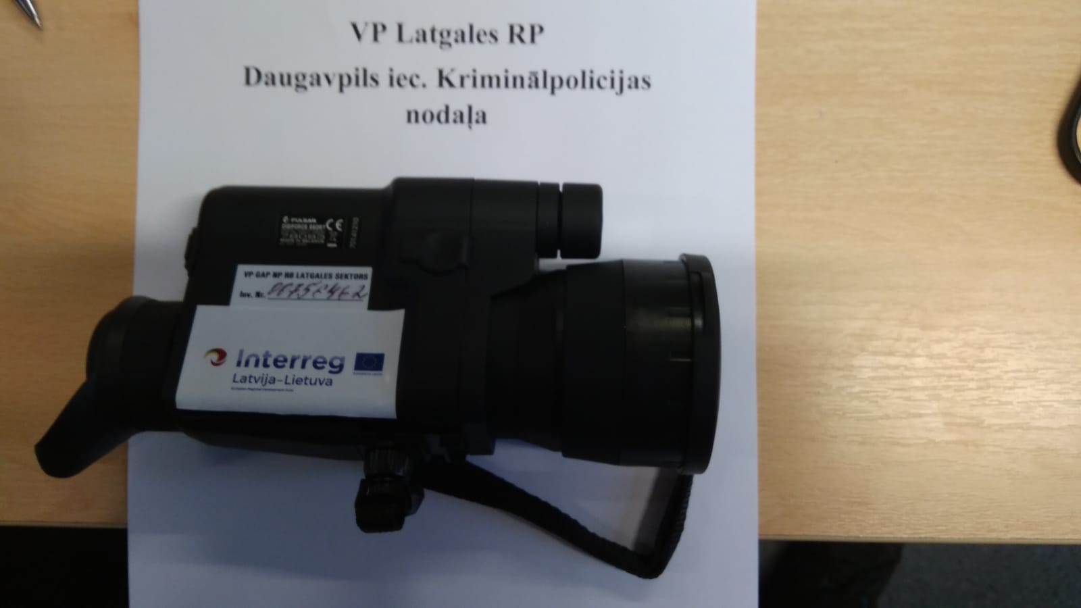
Night Vision Monocular with recording capability./ Nakts redzamības monoklis ar video ierakstīšanas funkciju Digforce 86ORT Digital NV Scope, 2pcs. | 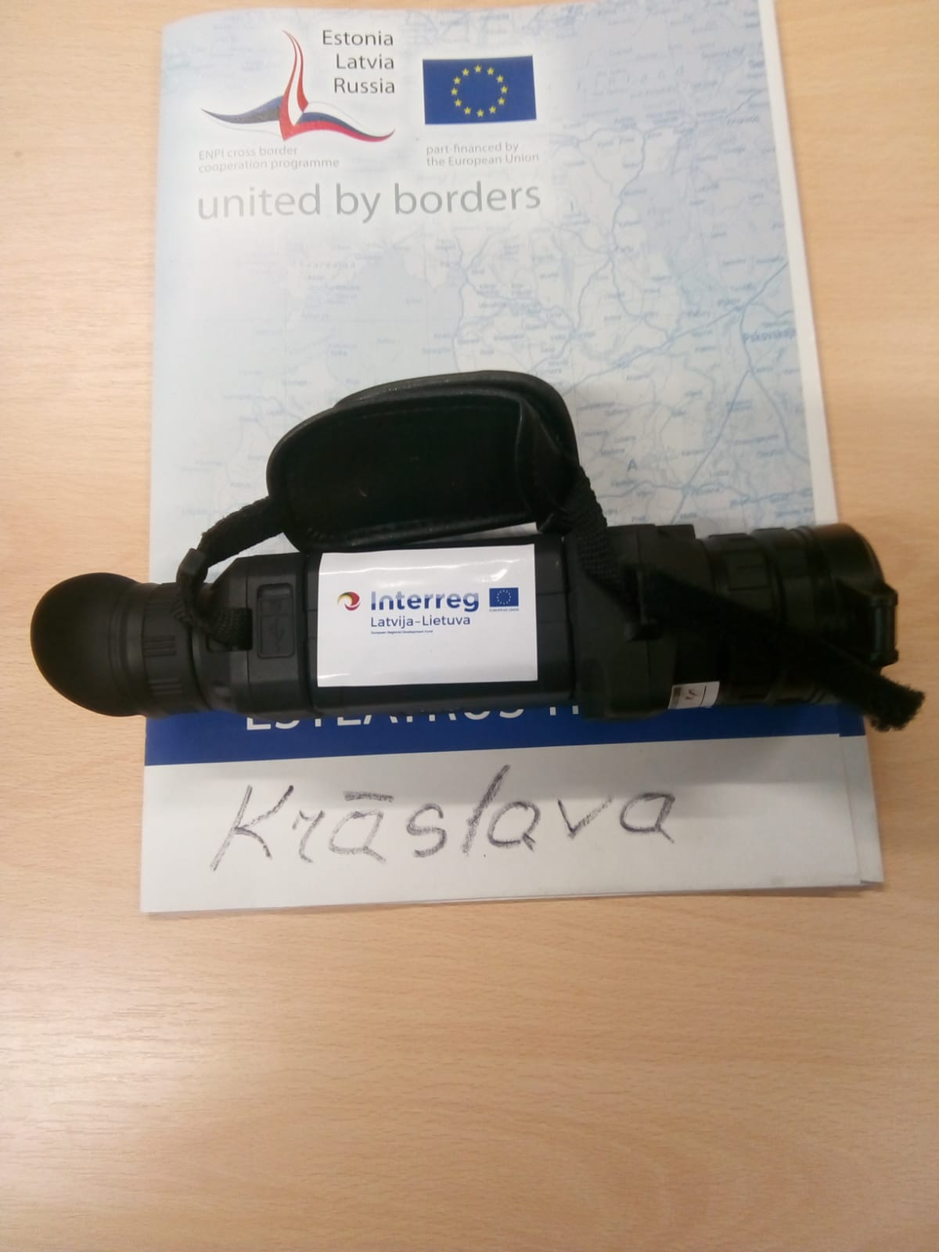
Snapshot Camera/ Uzraudzības kamera Snapshot Mobile Multi 3G 16MP HD meža kamera, 6 pcs. | 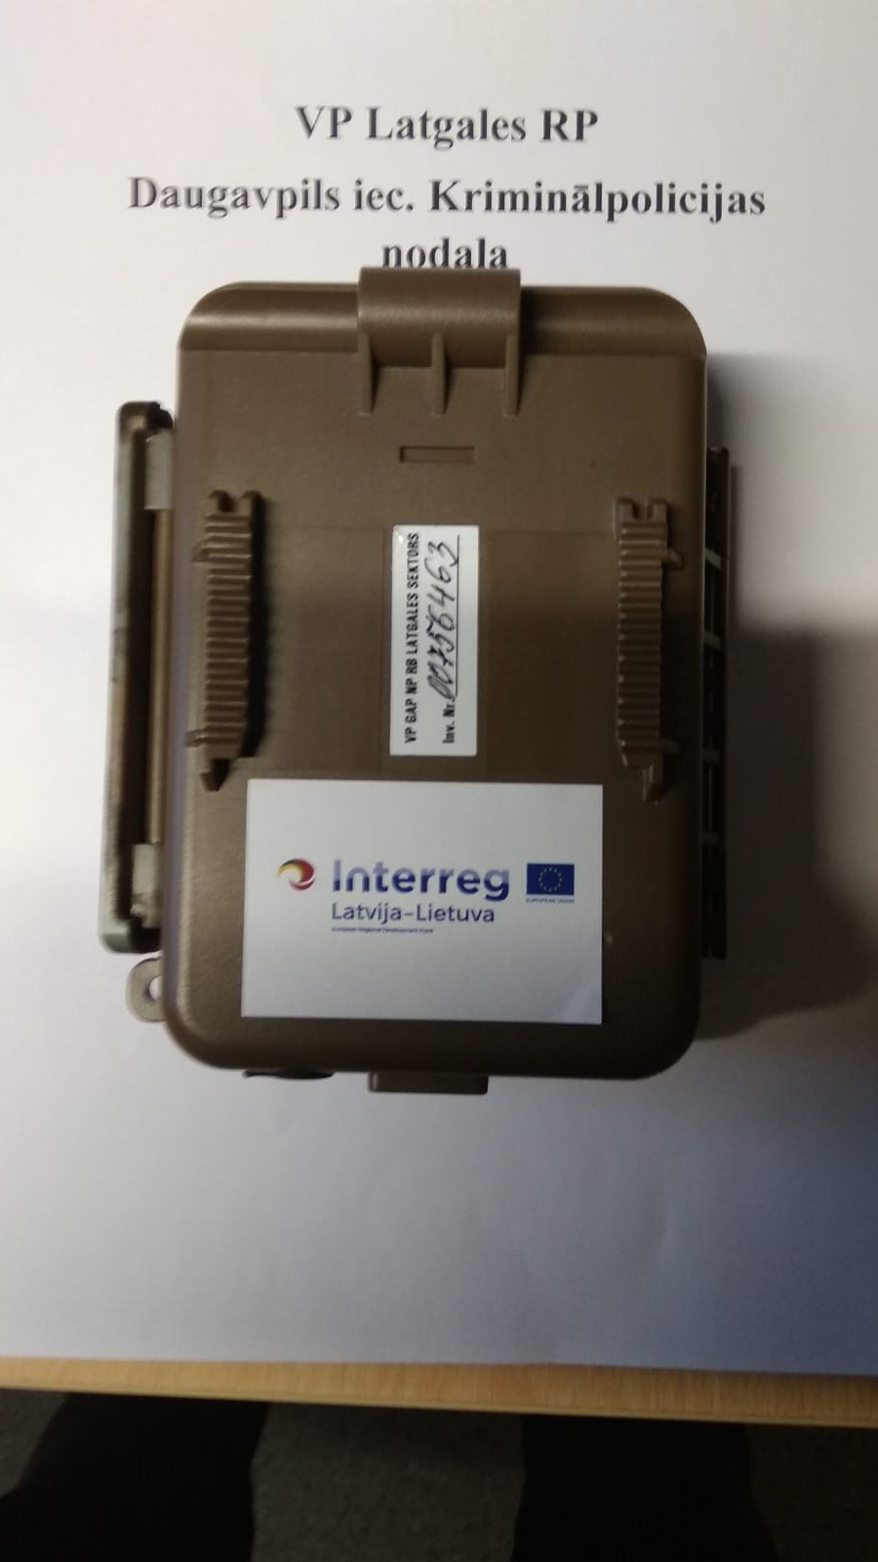

- PP2, Border Guard of Latvia acquired 4 Thermal Imaging Scopes, 4 Compact Video Recorders, 66 HD Driving Recorders with GPS, 79 Personal body cameras,1 Mirrorgless digital camera and 2 TVs for the video conferences;
Title | Picture
Fotokamera Nikon D750 + 24-120mm (Mirrorless digital camera with lens ​Nikon D750 24-120mm VR Kit; Цифровая зеркальная фотокамера – Nikon D750 24-120mm) | 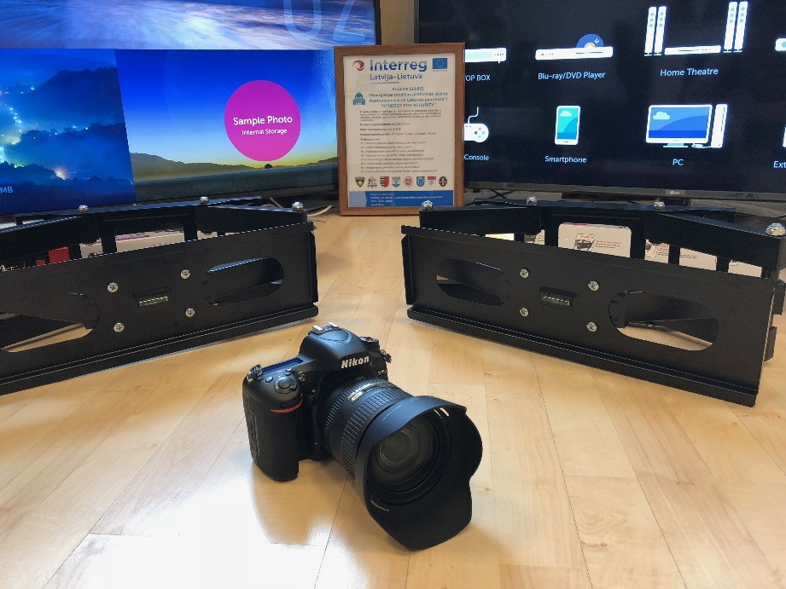
Televizors LG 60UJ634V  (tv for the videoconferences “LG 60UJ634V 60”; телевизора для видеоконференций – LG 60UJ634V); Sienas stiprinājums LED televizoram (wall mount for LED TV; kрепления для LED телевизоров) | 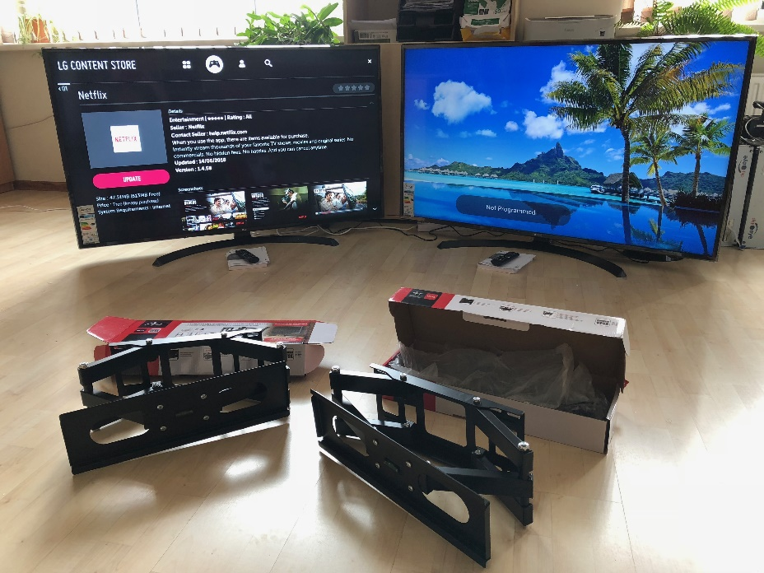
Termālā (pārnēsājamā) kamera Pulsar Helion XQ38F (thermal imaging scope "PULSAR Helion XQ38F”; портативных прибора ночного видения PULSAR Helion XQ38F) | 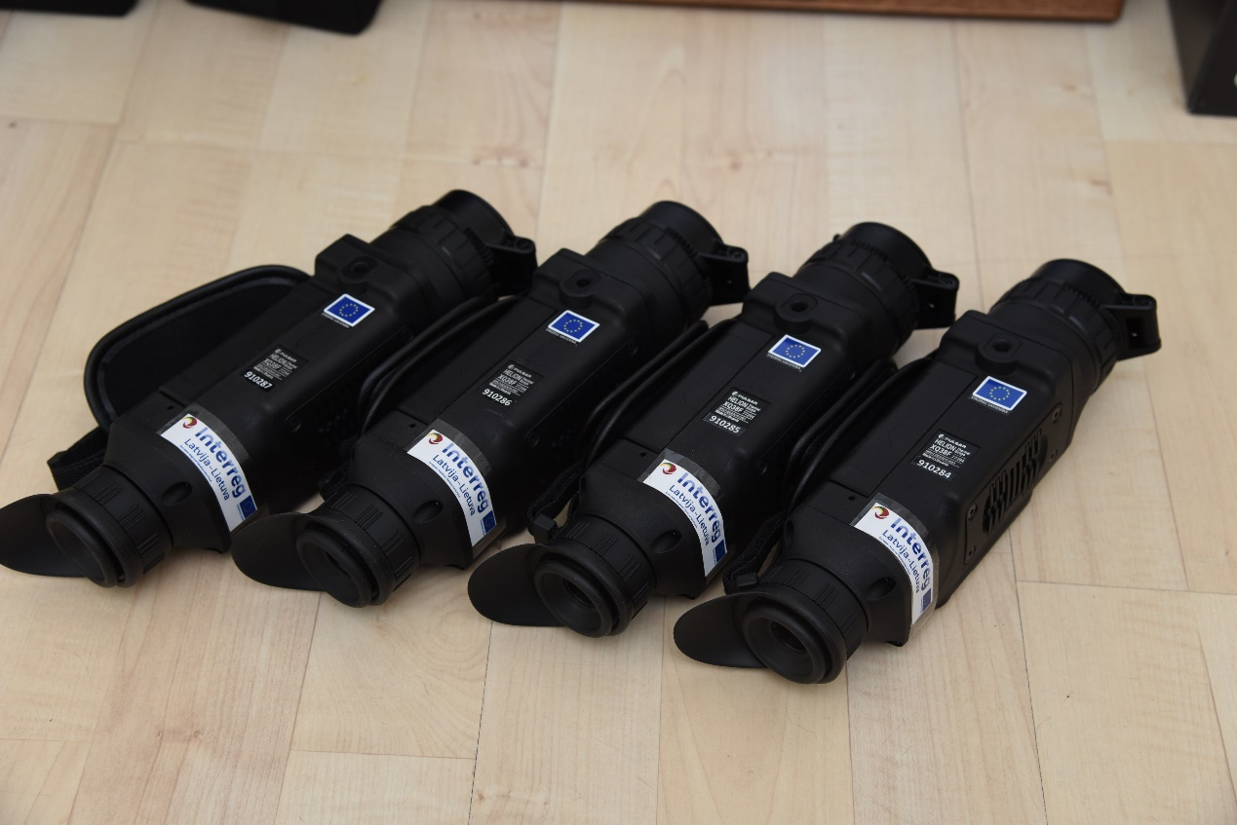
Video reģistrators ar GPS (HD driving recorder with GPS “GARMIN DASH CAM 45”; автомобильных видеорегистратора GARMIN DASH CAM 45) | 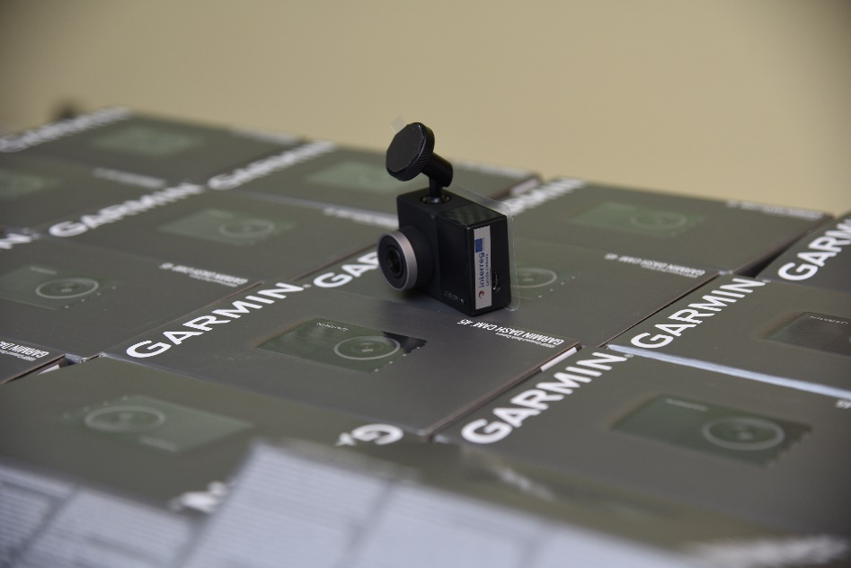
Individuālā videokamera S-Eye B (Personal body camera and doc station of the personal body camera; индивидуальных видеокамер Shelleyes S-Eye B);  Individuālo videokameru dokstacija DS02 (портативных док станций Shelleyes DS02) | 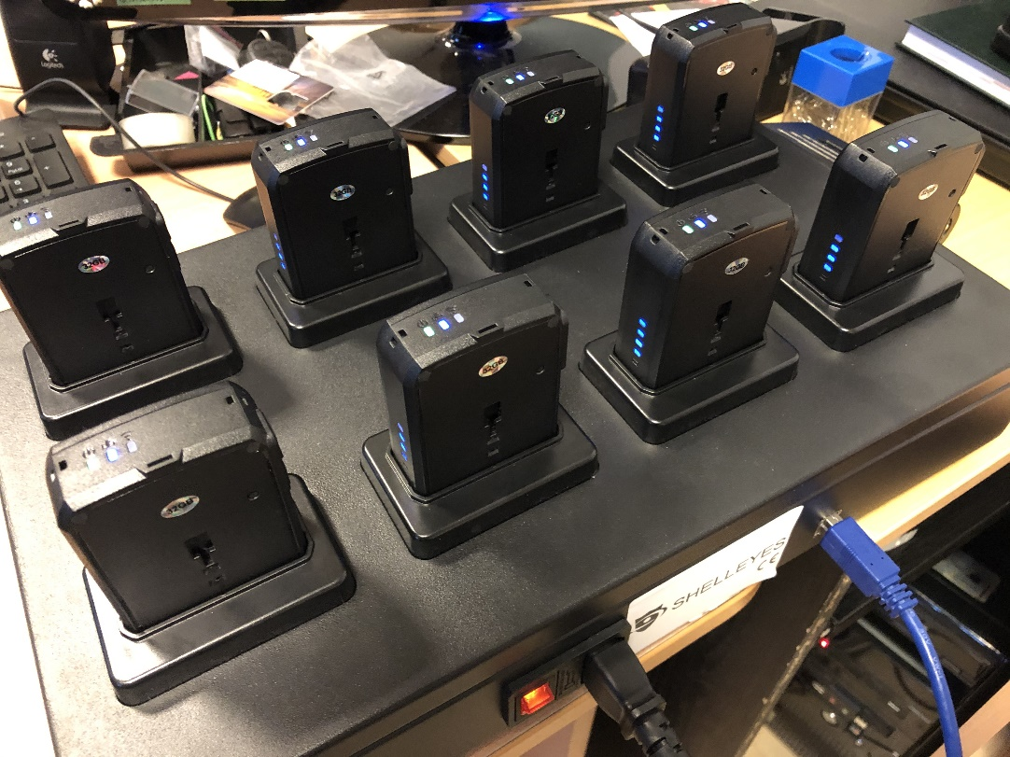
NAS - multifunctional data storage stations | 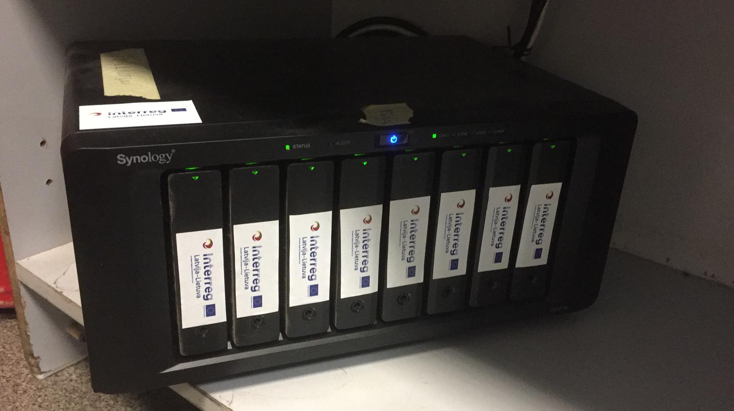
Internal hard disk for storing video information 24/7 | 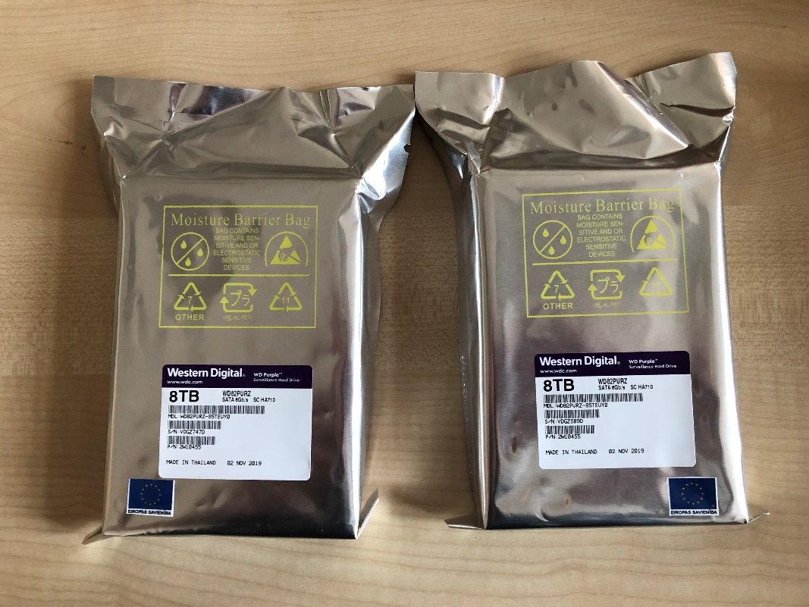
External hard drive | 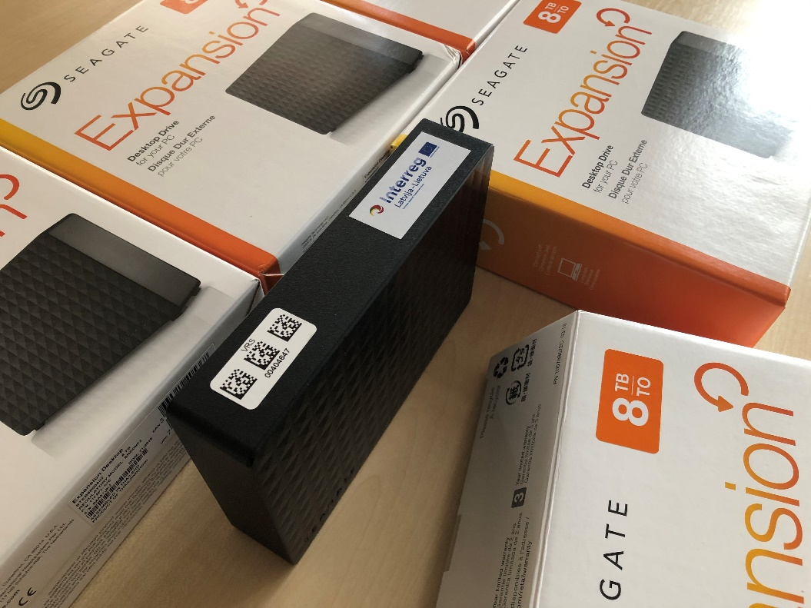

- PP5, Utena region police department acquired 3Night Vision Monocular, Thermal binoculars, Meeting/presentation tent, Interactive meeting board;

Attached in pdf format.
- PP8, State border guard of Lithuania acquired 3 thermal Imaging cameras, 3 vehicle video recorders, 2 PC, 2 Printers, 2 Wireless Router and 2 Video surveillance cameras with installation.
Title | Picture
Thermal imaging camera  Pulsar Helion XP50 | 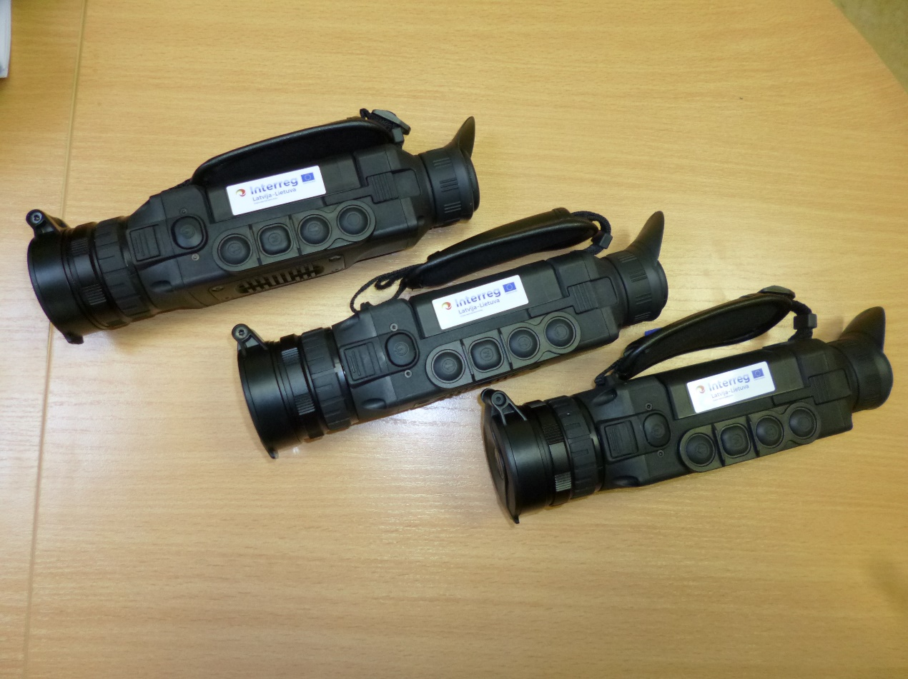
Camcorders and accessories | 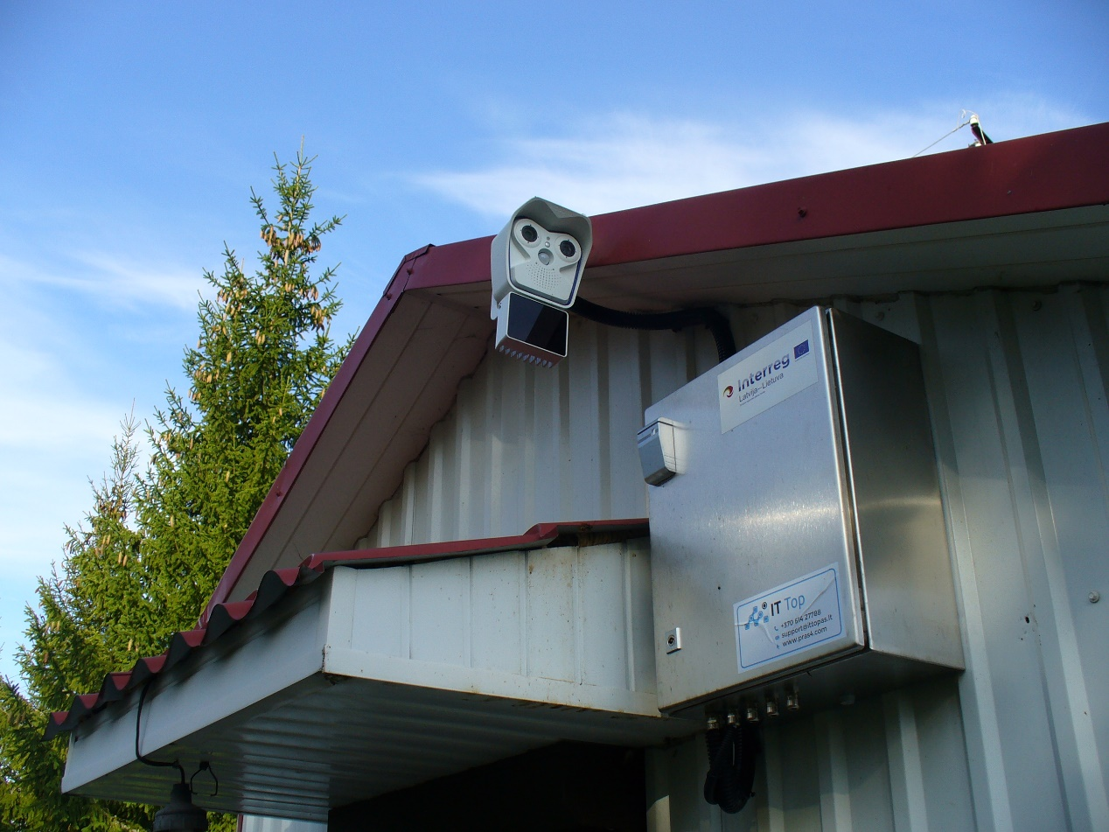
Camcorders and accessories | 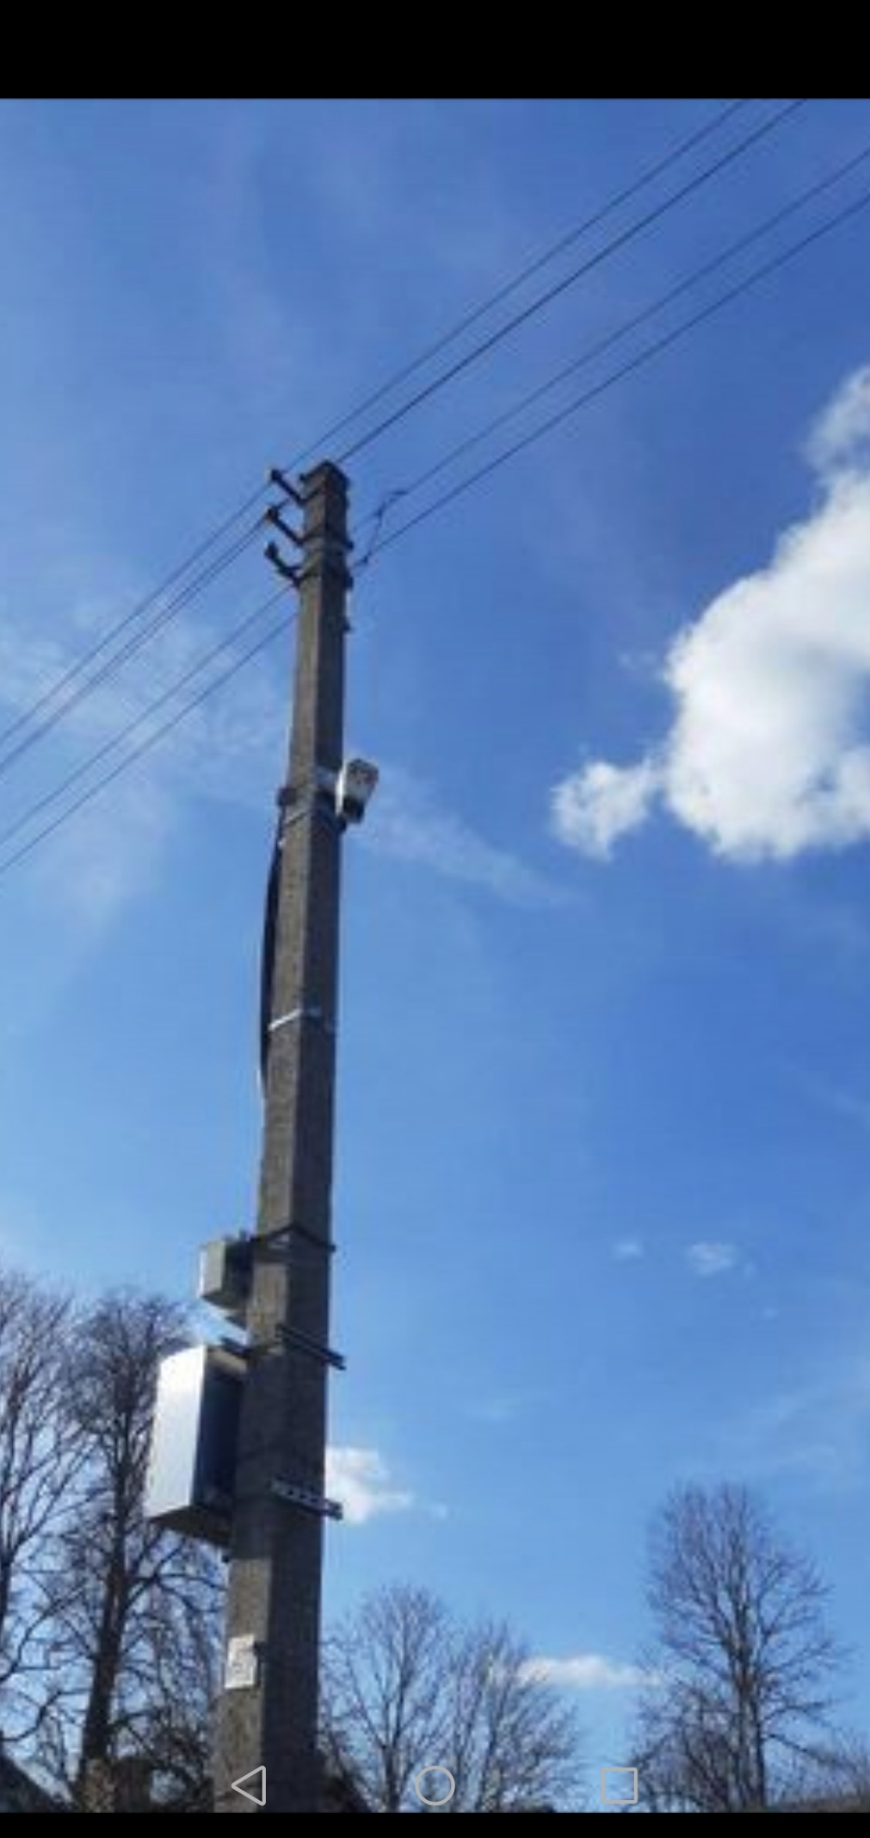
Laptop  Lenovo ThinkpadL490LTEi5-8265U14 | 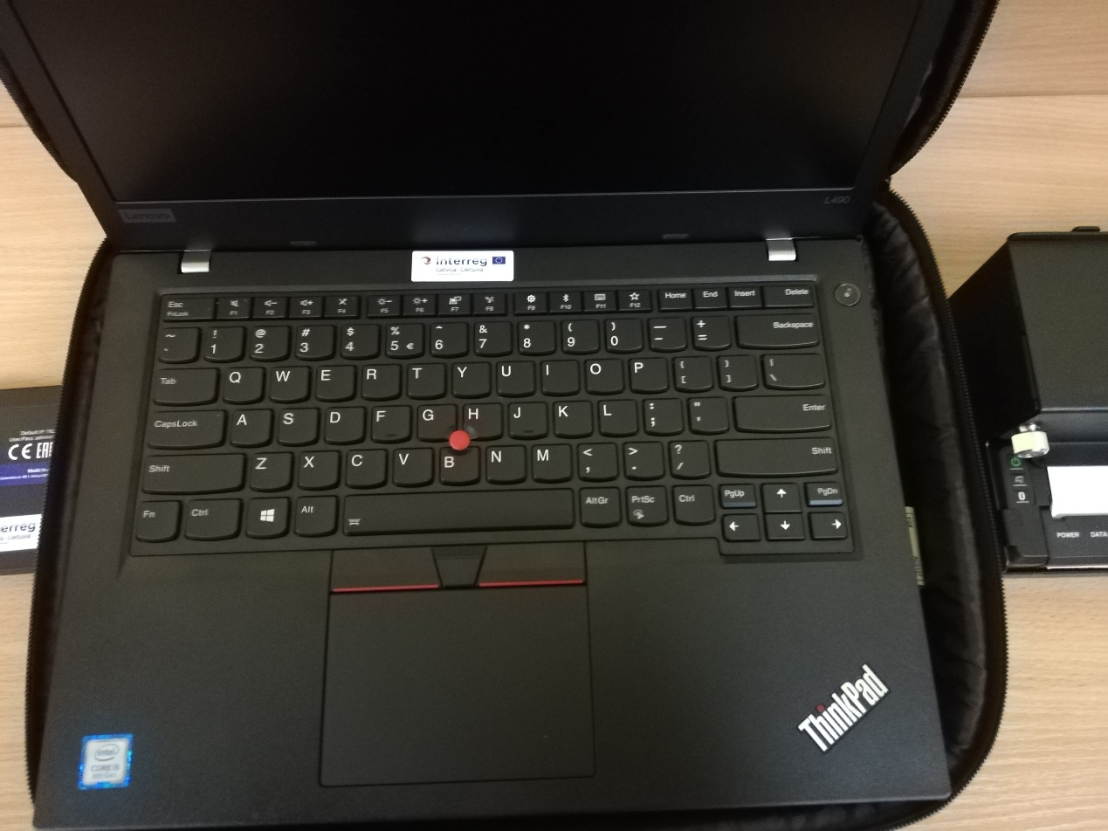
Laptop  Lenovo ThinkpadL490LTEi5-8265U14 | 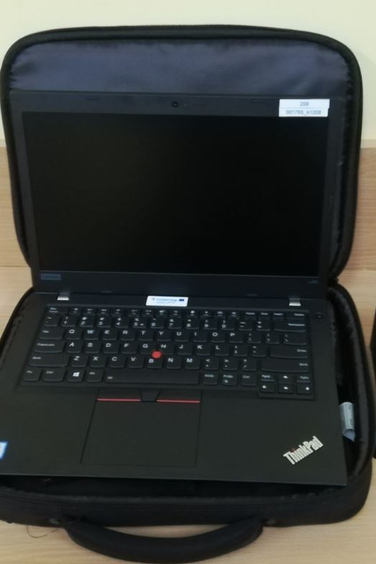
Video Recorder  LUKAS L7950 WD | 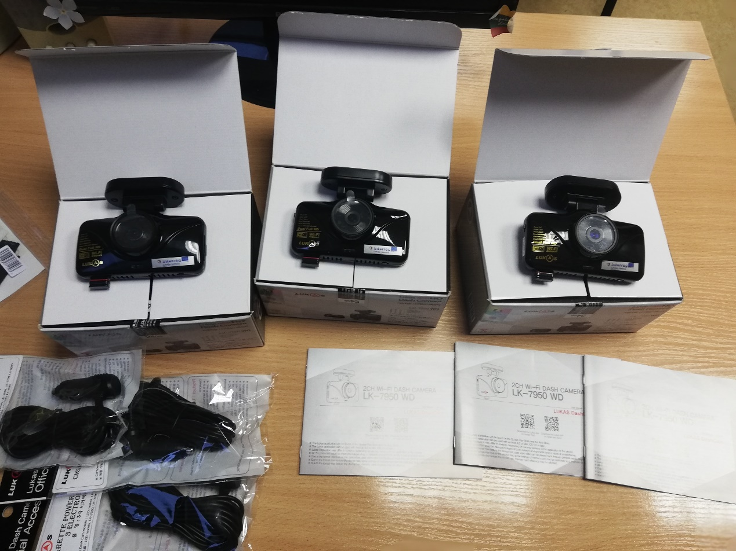
Camcorder connection license and automatic vehicle number recognition program | Photo not available

Acquired equipment have contributed into the prevention and public security issues.
The general public of the mentioned areas by the achieved main project outputs: Latvian and Lithuanian law enforcement authorities and 4 municipalities participated at the capacity building activities; Cross border network for the public security; Intelligent video surveillance platform with transport identity recognition software; Intelligent video surveillance systems for public security; Improvement of material bases, will benefit by the following:
- Visitors and the inhabitants of the project target area will have not only sense of security, but also really more safety area;
- As the locations of acquired video surveillance cameras is limited access information, it is challenge for existing and potential crimes to cross the borders criminally;
- As the Intelligent video surveillance platform with transport identity recognition software and Intelligent video surveillance systems for public security are used not only for monitoring the cross border crime but also used (with real results at this moment) for the public safety, the general public is more trust the capabilities of law enforcement institutions.

