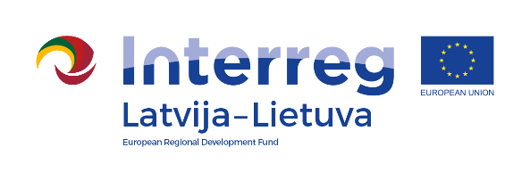
Interreg V-A Latvia–Lithuania Cross Border
Cooperation Programme 2014-2020

Project No. LLI-344 „Social partnership - integration of socially vulnerable people into community life“ (SocialLife)

The seminar
,,Improvement of seniors life quality“

AGENDA

28.02. 2019. – 01.03.2019.
Hotel “Rija Bauska Hotel”,
Slimnīcas street 7, Bauska, LV-3901, Latvia

First day 28th of February, 2019
"Is it easy to be old?"

9.00-9.30 | Arrival and registration. Coffee / tea
9.30 – 12.30 | - A social worker's understanding of the existence of the social role of an elderly person and resources.  - Getting new resources.
12.30- 13.00 | Lunch break.
13.00– 15.00 | - Understanding the seniors' basic emotions and emotional balance.  - Understanding of senior health, peculiarities of aging.
15.00 – 15.30 | Coffee / tea break
15.30– 17.30 | - Analysis of social workers' daily work experience situations with role play, settings, feedback and new model trainings. Work in groups.
18.00 – 19.00 | Dinner

Project partners:

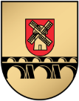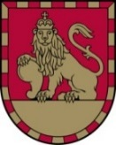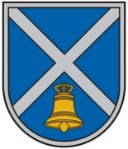
Interreg V-A Latvia–Lithuania Cross Border
Cooperation Programme 2014-2020

Project No. LLI-344 „Social partnership - integration of socially vulnerable people into community life“ (SocialLife)

The seminar
,,Improvement of seniors life quality“

Second day 1st of March, 2019

“ Is the social worker also aging?“
8.00 – 9.00 | Breakfast. Registration.
9.00 – 10.30 | - Meaning of Social worker’s support for seniors in their current life.  - The concepts of loneliness and uniqueness. How to work with them.
10.30-11.00 | Coffee / tea break
11.00– 12.30 | - Learn to understand that death is a part of life and how it is understood by the client.  - How to help to set the senior's goals for the nearest time and how to encourage to that senior is leader on their realization
12.30-13.00 | Lunch break.
13.00 – 14.30 | Understanding social work choice as a profession. Self-experience.
14.30 – 15.00 | Coffee / tea break
15.00 – 17.30 | - Relationship with personal aging. How to accept it, how to live and work with that still to be a professional social worker by own experience

Contact person in Iecava Local Municipality Administration:
Ineta Bramane, Project coordinator
Tel. No. +371 22006871, e-mail Ineta.bramane@iecava.lv

Project partners:

