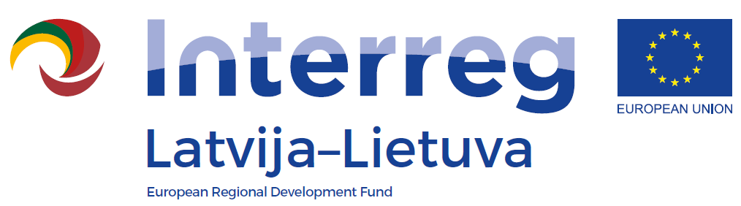
1st Call of the INTERREG V_A
Latvia-Lithuania Programme 2014-2020

LLI-110 Self-service libraries for different generations
Informative educational workshop “Making Comics strips”
AGENDA
Date: 11 April 2018
Venue: Jelgava City Library, Akademijas street 26, Jelgava
10:00 – 11.00 | Informative part about the comics genre, about the comics methods of production and technologies
11:00 – 11:05 | Break time
11:05 – 12.00 | Workshop: the comics creation

