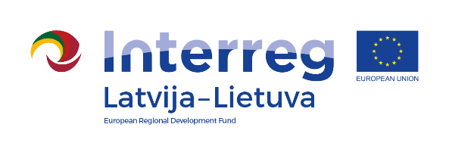
Interreg V-A Latvia–Lithuania Cross Border
Cooperation Programme 2014-2020

Project No. LLI-344 „Social partnership - integration of socially vulnerable people into community life“ (SocialLife)

The seminar ,,Social work realities. Strengthening motivation of
social workers“

AGENDA

26-27 th July, 2018
Hotel „Metropolis“, S. Daukanto street 21, LT-44249 Kaunas, Lithuania

First day
9.30-10.00 | Registration. Coffee / tea
10.00 – 12.15 | Motivation conseption and consept. Motivational strengthening and weakening factors. Motivation theories (A. Maslow; Self-Determination Theory; Model of needs and resources) and their application at work.
12.15 – 13.15 | Lunch break.
13.15 – 14.45 | Motivation in social work: the influence of internal (autonomous) and controlled motivation. The aims: GROW model. Internal rules, self-confidence, personal philosophy and its analysis process.
14.45 – 15.05 | Coffee / tea break
15.05 – 17.20 | Burnout syndrome and possibilities to prevent it. Crisis and change management. Practical recommendations and relaxation exercises.
17.20 – 18.20 | Dinner

Project partners:

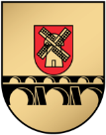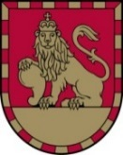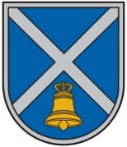

Interreg V-A Latvia–Lithuania Cross Border
Cooperation Programme 2014-2020

Project No. LLI-344 „Social partnership - integration of socially vulnerable people into community life“ (SocialLife)

The seminar ,,Social work realities. Strengthening motivation of
social workers“

Second day
8.00 – 8.55 | Breakfast. Registration.
8.55 – 9.40 | The realities of social work. The best practice of social work in Pakruojis district.
9.40 – 10.00 | Coffee / tea break
10.00 – 12.15 | Visiting social institutions:  Kaunas District Social Services Center  Kaunas District Social Services Center’s the Center for the Disabled people  Non-governmental organization ,,Family relationship institute”
12.15 – 13.15 | Lunch break.
13.15 – 15.30 | Visiting social institution:  Kaunas Generation Home
15.30 – 15.50 | Coffee / tea break
15.50 – 16.35 | The summarizing of the seminar and the best practice from visited social institutions of Kaunas district.

Contact person in Pakruojis District Municipality Administration:
Daiva Rutkevičienė, Project coordinator
Tel. No. +370 421 69074, +370 687 21005, e-mail daiva.rutkeviciene@pakruojis.lt

Project partners:

