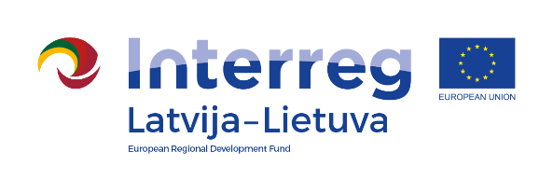
Interreg V-A Latvia–Lithuania Cross Border
Cooperation Programme 2014-2020

Project No. LLI-344 „Social partnership - integration of socially vulnerable people into community life“ (SocialLife)

The seminar
,,Persons with mental deseases.
Work with them and integration into society“

AGENDA

30-31th August, 2018
Hotel „Senlīči Hotel“, adress „Līči“, Jaunsvirlauka parish,
Jelgava local municipality, LV-3001, Latvia

First day „Methods of creativity in dealing with persons with mental disabilities“
9.00-9.30 | Arrival and registration. Coffee / tea
9.30 – 12.30 | - Creativity and the development and importance of creative thinking.  - How to develop a capacity in a daily routine, problems, see an exit in the crisis, find a non-standard solution and transform an existing problem into a new, unique, positive level.
12.30- 13.00 | Lunch break.
13.00– 15.00 | - Intentional training of purge, contentment and creative imaginations.  - Methods of creativity to reduce stress and anxiety
15.00 – 15.30 | Coffee / tea break
15.30– 17.30 | - The specific of the organisation of creativity activities for people with mental disabilities
18.00 – 19.00 | Dinner

Project partners:

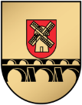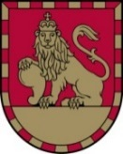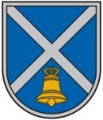
Interreg V-A Latvia–Lithuania Cross Border
Cooperation Programme 2014-2020

Project No. LLI-344 „Social partnership - integration of socially vulnerable people into community life“ (SocialLife)

The seminar ,,Persons with mental deseases.
Work with them and integration into society“

Second day “Stress management and stress mitigation methods
for employees and social services clients“
8.00 – 9.00 | Breakfast. Registration.
9.00 – 10.30 | - What is stress? How does this affect our organism and thinking? Good and bad stress;  - Features of burning out. How is the fire going? How to notice and fix it in a timely manner?
10.30-11.00 | Coffee / tea break
11.00– 12.30 | - Stressors. Good and bad stressors. What are they? How do they work?  - The effects of the hypothalamic - pituitary - adrenal (HHV) gland axis dysfunction
12.30-13.00 | Lunch break.
13.00 – 14.30 | - Stress hormones. Increased cortisol. What to do?  - Usage of the stress reduction method for people with mental disabilities
14.30 – 15.00 | Coffee / tea break
15.00 – 17.30 | Practical part:  - To reduce the stress of consciousness activation techniques.  - Practical improvement recommendations.  The summarizing of the seminar.

Contact person in Iecava Local Municipality Administration:
Ineta Bramane, Project coordinator
Tel. No. +371 22006871, e-mail Ineta.bramane@iecava.lv

Project partners:

