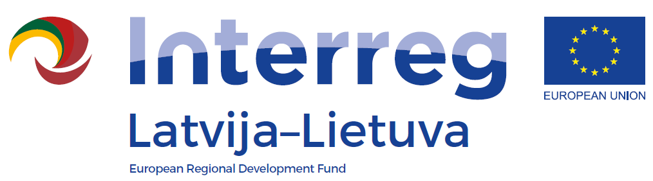
Seminar on project implementation INTERREG V_A
Latvia-Lithuania Programme 2014-2020

LLI-110 Self-service libraries for different generations
Cross border experience exchange workshop
AGENDA
Date: 21 August 2018
Venue: Jelgava City Library, Akademijas street 26, Jelgava
10.30 – 11.00 | Arrival, registration and coffee
11.00 – 11.15 | Welcoming
11.15 – 11.45 | The presentation of Jelgava City Library “Story of experience or how to thinking out of the box”
11.45 – 12.20 | Lego Mindstorms EV3 robot presentation.
12.20 – 12.45 | The “Story quilt” exhibition in the Jelgava City Library
12.45– 13.30 | Lunch
13.30 – 14.45 | Relaxing workshop prepared by Jelgava City Library director Lāsma Zariņa

