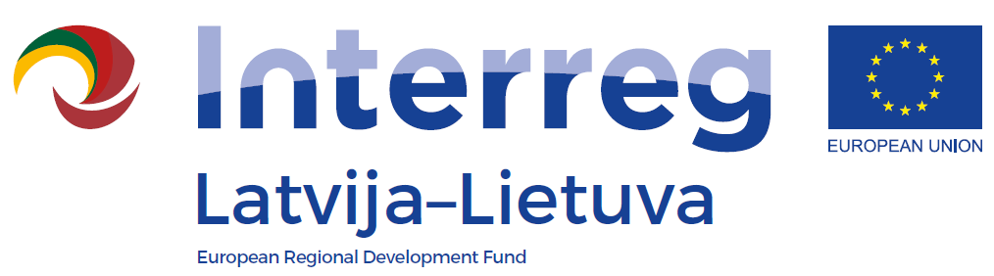
Capacity building workshop for LLI-349 project
within the INTERREG V-A
Latvia-Lithuania Programme 2014-2020

AGENDA OF CAPACITY BUILDING WORKSHOP
Project No: LLI-349 „Development of eco-tourism by using water resources in Latvia and Lithuania”
10-11.10.2018
Place: Anykščiai Art Incubator, J. Biliūno st. 53, 29110 Anykščiai, Lithuania

October 10, 2018
9:30 – 10:00 | Arrival, registration, coffee
10:00 – 12:00 | Development of Eco tourism, / Eglė Ližaitytė, LT/
12:00 – 13:00 | Lunch
13:00 – 14:00 | Visit of the observation deck of Anykščiai church of st. Matthew the apostile and evangelist  https://www.infoanyksciai.lt/lankytinos-vietos/apzvalgos-aikstele-anyksciu-sv-apastalo-evangelisto-mato-baznycios-bokste/
14:00 – 15:00 | Creating of attractive, interesting tourism products, I part /Juris Smaļinskis, LV/
15:00 – 15:20 | Coffee break
15:20 – 17:20 | Creating of attractive, interesting tourism products, II part /Juris Smaļinskis, LV/
17:20 – 17:45 | Questions and answer session
18:30 | Dinner

October 11, 2018
8:30 – 10:00 | Expectation and needs of tourists today, I part / Ramutė Narkūnienė/
10:00 – 10:15 | Coffee break
10:15 – 11:30 | Anykščiai Regional Park's Visitor Centre  https://www.infoanyksciai.lt/en/sightseeing-places/anyksciai-regional-park-visitor-s-centre/
11:30 – 12:30 | Expectation and needs of tourists today, II part / Ramutė Narkūnienė/
12:30 – 13:30 | Lunch
13:30 – 14:30 | Marketing of eco-tourism products, possibilities of social networks, I part /Liene Kupča/
14:30 – 14:45 | Coffee break
14:45 – 16:45 | Marketing of eco-tourism products, possibilities of social networks, II part /Liene Kupča/
16:45 – 17:00 | Questions and answer session  Evaluation of the seminar

Working language of the Seminar: Latvian and Lithuanian languages
Participants: local tourism entrepreneurs from Latvia and Lithuania, specialists of tourism information centre (LV and LT) and project coordinators (LV and LT).
Capacity building training is organized by Anyksciai Municipality and Preiļi County Council.

