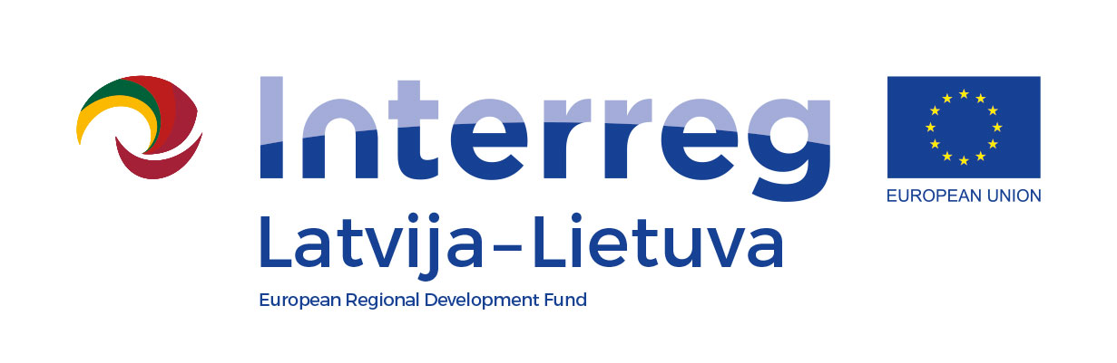
Project number
Project title
Project acronym
Lead Partner (LP)
Project duration

Final report
1. | Achievement of the project overall objective and specific objectives
1.1. | Please describe how project overall objective and sub-objectives laid down in the project application form were achieved. While describing achievements of objectives, please be specific as possible and try to identify measurable achievements.
2. | Information on achieved project main outputs
2.1. | Describe achieved project main outputs, their added value and users.
3. | Contribution to Programme output and result indicators
3.1. | Describe achieved project main output’s target value and its contribution to Programme output indicator.
3.2. | Describe contribution to Programme result indicator with quantification of achieved target value, if possible.
4. | Durability of project results - how project main outputs produced will be used after the project end
4.1. | Specify concrete actions to be taken to ensure the durability of outputs produced (who will be owner of project outputs; who will finance activities after project end and from which funds)
4.2. | Provide concrete details on how and where project main outputs will be accessible (for example, mention the geographical location of the tourism destination, provide the web address where the e-tool is available, etc.)
4.3. | Specify to what extent project main outputs are applicable and replicable by other organisations/regions/countries outside of the current partnership and what concrete measures have been planned to achieve this.
5. | Impact of the project to the target group(s) (end users)
5.1. | Describe the effect on project target group that was reached by achievement of project outputs. What is the benefit for target group(s) from produced project outputs?
6. | Benefits of cross-border approach
6.1. | Explain the advantages of cross-border cooperation and describe the expected social-economic benefits of the project for the cross-border region.
7. | Contribution to EU Strategy for the Baltic Sea Region
7.1. | Please describe how the project with its achieved project main outputs has contributed to EU Strategy for the Baltic Sea Region.
8. | Project challenges
8.1. | Describe the challenges (partnership, activity plan, budget, communication, etc.) your project faced during implementation, their reasons and solutions.
9. | Feedback to Latvia-Lithuania Programme
9.1. | Provide feedback to the Programme’s Joint Secretariat and Managing Authority on your experiences on working with the Latvia-Lithuania Programme.

