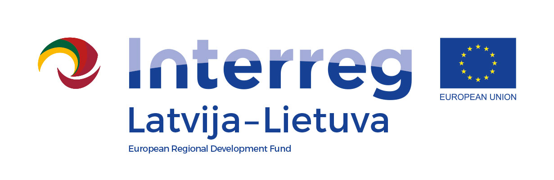
Project number
Project title
Project acronym
Name of Lead Partner/Project partner

Statement after project implementation
By signing this statement we confirm that:
- We are aware on rules set in the Article 61 and 65 of Regulation (EU) No 1303/2013 of the European Parliament and of the Council of 17 December 2013 laying down common provisions on the European Regional Development Fund, the European Social Fund, the Cohesion Fund, the European Agricultural Fund for Rural Development and the European Maritime and Fisheries Fund and laying down general provisions on the European Regional Development Fund, the European Social Fund, the Cohesion Fund and the European Maritime and Fisheries Fund and repealing Council Regulation (EC) No 1083/2006 and section 10.3 of the Programme Manual of Interreg V-A Latvia–Lithuania Programme 2014–2020 (hereinafter - Programme). Therefore we confirm that:
☐ no net revenue was planned and generated during the Project duration according to definition stated in Programme Methodology on calculation of discounted net revenue and net revenue (hereinafter – Methodology);
or
☐ no net revenue was planned during Project duration however net revenue generated during the Project implementation is calculated and deducted from the eligible Project budget according to the Methodology;
or
☐ net revenue generated within the Project duration was calculated and deducted from the eligible Project budget according to the Methodology and no additional revenue was generated during the Project implementation;
or
□ net revenue generated within the Project duration was calculated and deducted from the eligible Project budget according to the Methodology and additional revenue generated during the Project implementation is calculated and deducted from the eligible Project budget according to the Methodology.
- The Programme rules on information and publicity will be respected after the Project end date for all outputs and results produced within the Programme according to requirements stated in section 8 ‘Information and communication requirements’ of the Programme Manual and Programme Communication guidelines.
- We will not make a substantial change in project main outputs affecting project nature, objectives or implementation conditions which would results in undermining its original objectives.
- Without prior consent of the MA, We will not transfer ownership, titles, industrial and intellectual property rights for outputs of the Project related to investment in infrastructure, durable equipment items and/or productive investment at least 5 (five) years after the final payment to the Project has been made.
- We are fully aware that not fulfilling conditions meant under points 3 and 4 can imply a recovery of the funds unduly paid.
- ☐ We inform that following fixed assets were purchased and/or created within the Project:
Inventory number | Title of fixed asset | Location address | End of depreciation period (dd/mm/yyyy)
or
☐ we confirm that no fixed assets were purchased and/or created within the Project.
- We will retain all files, documents and data about the Project on standard data storage media in a safe and orderly manner for control and audit purposes at least five years after the final payment to the Project has been made.
- Our institution’s contact person that might be contacted on any Project related matter after Project implementation is specified in Electronic Monitoring System (hereinafter - eMS) section ‘Supplementary information/Documents’. In case of contact person change, the information in eMS will be updated immediately.

Official title of the organisation in English
Name and position of the authorised representative
Signature
Date of signature

This document has to be submitted by all project partners (including the Lead partner) together with the Project report for the last reporting period.

