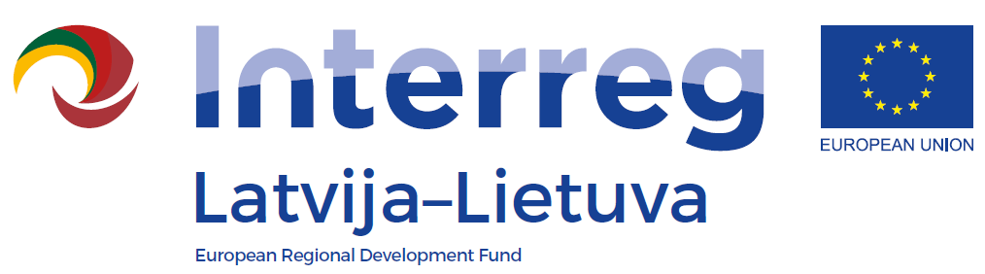
Seminar of the INTERREG V_A
Latvia-Lithuania Programme 2014-2020

LLI-110 Self-service libraries for different generations
Family competition “Know or guess“
AGENDA
Date: 8 December, 2018
Venue: Siauliai City Municipality Public Library, K. Korsako str. 10, Siauliai
11.30 – 12.00 | Arrival, registration and coffee, snacks
12.00 – 12.10 | Welcoming
12.10 – 14.00 | Family competition “Know or guess“
14.00 – 14.30 | Visiting and education activities for families in the different “Saule” library places (Comics center, Family space, Foreign language learning center)  Coffe, snacks
14.30 – 15.00 | Arriving to the museums –  Photography museum (Vilniaus str. 140, Šiauliai) – for Liepaja’s library (English language)  Bicycle Museum ( Vilniaus str. 139, Šiauliai) – for Jelgava’s library (Russian language)  Chaim Frenkel Villa (Vilniaus str. 74, Šiauliai) – for Siauliai city municipality public library (Lithuanian language)
15.00 – 16.30 | Visiting museums

