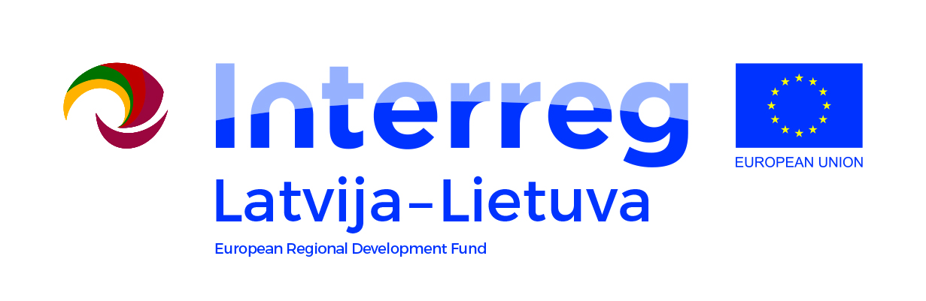

Interreg V-A Latvia – Lithuania Programme 2014-2020

LLI-131 Creating of business support system and the availability in Zemgale, Kurzeme and Northern Lithuania/
BUSINESS SUPPORT

Facebook Training for Business
AGENDA
Venue Taikos 19, Rokiškis LT-42114
Date 26.03.2019
Working language Lithuanian
Lecturer Daugvinas Liberis

Tuesday | the 26th of March, 2019
09:45 – 10:00 | Registration, coffee
10:00 – 11:30 | - Facebook algorithm  - Business goals on Facebook and the Internet – micro and macro conversations  - Facebook pixel –advertisement results tracking and audience generating tool
11:30 – 11:45 | Coffee/tea break
11:45 – 13:00 | - Audiences – segmenting, targeting and application on Facebook
13:00 – 14:00 | Lunch break
14:00 – 16:30 | - Placements  - Content for each audience recommendations  - Results analysis and optimization  - Facebook as a tool to test communication and creatives
16:30 – 17:00 | Questions – Answers

More information and registration: rasavingeliene71@gmail.com, +370 61638688.

