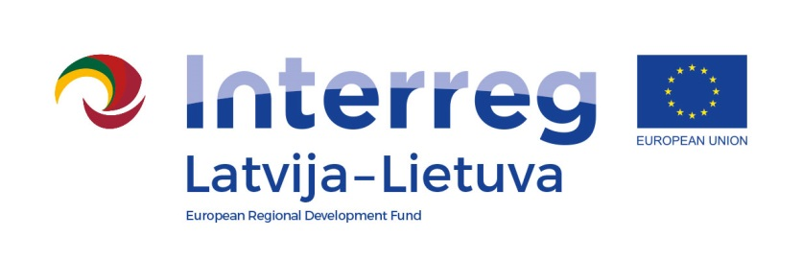

Interreg V-A Latvia – Lithuania Programme 2014-2020

LLI-131 Creating of business support system and the availability in Zemgale, Kurzeme and Northern Lithuania/
BUSINESS SUPPORT

Training
“Quality management focused on customer satisfaction”
AGENDA
Venue Taikos 19, Rokiškis LT-42114
Date 25.03.209
Working language Lithuanian
Lecturer Kęstutis Jasiūnas

Monday | the 25th of March, 2019
09:45 – 10:00 | Registration, coffee
10:00 – 10:15 | Introduction, goals
10:15 – 11:30 | - Principles of quality management  - Practical exercise "BUM"
11:30 – 11:45 | Coffee/tea break
11:45 – 13:00 | - Process management  - Increasing operational efficiency - a practical exercise  - Personnel management
13:00 – 14:00 | Lunch break
14:00 – 16:30 | - Change management  - Feedback management
16:30 – 17:00 | Summary of the day, questions

More information and registration: rasavingeliene71@gmail.com, +370 61638688.

