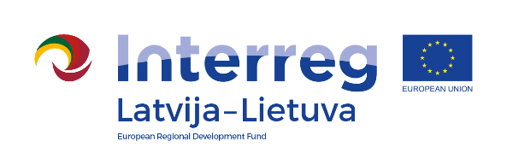
Interreg V-A Latvia–Lithuania Cross Border
Cooperation Programme 2014-2020

Project No. „Social Partnership - Integration of Socially Vulnerable People Into Community Life“ (SocialLife)

International Day of Older Persons

D.T2.4.1

AGENDA

01.10.2019
Pakruojis Culture Center, Vienybės square 1, Pakruojis

9.00 – 10.00 | Arrival, registration
10.00 – 10.10 | Musical greeting of Klovainiai Youth Center with intellectual disabilities
10.10 – 10.30 | Greetings from project partners
10.30 – 10.40 | Performance of Seniors dance group “Magnolia” from Rundale Municipality, Latvia
10.40 – 10.50 | Performance of Drama Therapy Group from Rundale Municipality, Latvia
10.50 – 11.10 | Performance of Iecava Senior dance group “Bumblebee”, Latvia
11.10 – 11.30 | Pakruojis seniors choir performance
11.30 – 12.30 | Discussions at the cup of tea (coffee)
12.30 – 13.00 | Sightseeing tour to Pakruojis synagogue, Kranto street 8, Pakruojis
13.00 – 14.00 | Sightseeing tour to Pakruojis manour

Contact person in Pakruojis District Municipality Administration:
Daiva Rutkevičienė, Deputy project manager
Tel. No. +370 421 69074, +370 687 21005, e-mail daiva.rutkeviciene@pakruojis.lt

Project partners:

