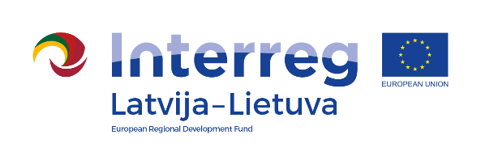
Interreg V-A Latvia–Lithuania Cross Border
Cooperation Programme 2014-2020

Project No. „Social Partnership - Integration of Socially Vulnerable People Into Community Life“ (SocialLife)

International Day of Persons with Disabilities

D.T2.4.1

AGENDA

06.12.2019
Pakruojis Culture Center, Vienybės square 1, Pakruojis

9.00 – 11.00 | Arrival, registration
9.00 – 13.00 | Handicraft fair
11.00 – 13.00 | Festive event "Christmas Tale":  Greetings.  Artistic performances of social institutions (participate collectives from Pakruojis, Rundale and Iecava)
13.00 – 14.00 | Discussions at the cup of tea (coffee)

Photos and videos will be taken during the event.

Contact person in Pakruojis District Municipality Administration:
Daiva Rutkevičienė, Deputy project manager
Tel. No. +370 421 69074, +370 687 21005, e-mail daiva.rutkeviciene@pakruojis.lt

Project partners:

