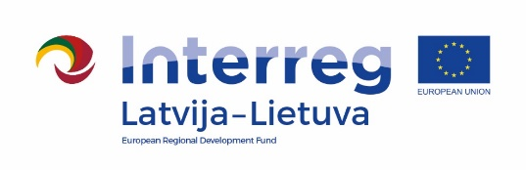
Report on suspected fraud/wrongdoing
I hereby inform the Managing Authority/Joint Secretariat of the Interreg V-A Latvia – Lithuania Programme 2014 – 2020 that I have found evidence of or become aware of suspected fraud/wrongdoing for the following project partner (template of this report is filled out to my knowledge):
Project number
Project acronym
Project title
Name of project partner organisation
- Typology of suspected fraud/wrongdoing
Please explain in detail the nature of suspected fraud/wrongdoing about which you wish to inform the Managing Authority/Joint Secretariat of the Interreg V-A Latvia – Lithuania Programme 2014 – 2020 about (some examples of fraud are conflict of interests, fake declarations, double funding, etc.)
- Financial perimeter of the suspected fraud/wrongdoing
Amount of expenditure concerned (in EUR)
Concerned project partner report(s)
Concerned budget line(s) or the combination
BL1 Staff costs
BL2 Office and administration
BL3 Travel and accommodation costs
BL4 External expertise and services costs
BL5 Equipment costs
BL6 Infrastructure and works
- Founding principles leading to fraud suspicion/wrongdoing
Please explain in detail the reasons/circumstances leading you to suspect the existence of fraud/wrongdoing for this specific project partner (i.e. why do you think there may be fraud/wrongdoing? How did you become aware of the suspected fraud/wrongdoing?)
Please provide some concrete facts or details about the suspicion of fraud/wrongdoing (including reference of the competent authority/court decision for established fraud)
Please indicate the actions you already undertook to analyze the specific case in-depth.
Please also specify if you reported this suspected fraud/wrongdoing to any other competent authority and/or initiated any administrative or judicial proceedings in relation to this case.
- Potential impact of the suspected fraud/wrongdoing outside the project
If applicable, please list other EU co-funded programmes and projects in which the same beneficiary is involved (to your knowledge).
Please add any complementary indication you deem useful to identify and limit the impact of the suspected fraud/wrongdoing.
I hereby declare that the above information is, to the best of my knowledge, complete, accurate and true.
I am aware that the Managing Authority/Joint Secretariat of the Interreg V-A Latvia – Lithuania Programme 2014 – 2020 and national competent bodies may use this information for undertaking further investigations and appropriate legal actions in relation to suspected unlawful activity if required.
Additional voluntary information by the person reporting the suspected fraud/wrongdoing:

