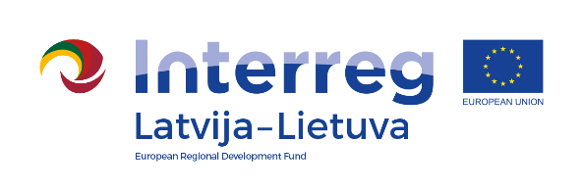
Interreg V-A Latvia–Lithuania Cross Border
Cooperation Programme 2014-2020

Project No. LLI-344 „Social partnership - integration of socially vulnerable people into community life“ (SocialLife)

Project Closing conference

AGENDA
30th October, 2020

Kęstučio street 4, LT-83152 Pakruojis, Lithuania
10:00 – 10:15 | Registration
10:15 – 10:30 | Presentation of project results in LP  Lina Mikolaitytė,  Chief officer of Investment and Asset Management Division of Pakruojis District Municipality Administration
10:30 – 11:00 | Presentation of implemented project activities in Linkuva social services center  Renata Žiedienė, Linkuva social services center
11:00 – 11:15 | Presentation of project results in PP2  Rundale Local Municipality
11:15 – 11:35 | Presentation of implemented project activities in Rundale Local Municipality  Rundale Local Municipality
11:35 – 11:50 | Presentation of project results in PP3  Administration of Iecava County Municipality
11:50 – 12:10 | Presentation of implemented project activities in Rundale Local Municipality  Administration of Iecava County Municipality
12:10 – 12:20 | Discussions

The conference will be held remotely (using Zoom). Please register by e-mail socrupyba@pakruojis.lt till 28th October 2020, sending contacts of participants (name, last name, organization, position, phone number, e-mail). The link to the conference will be send to registered participants by e-mail.

Contact person in Pakruojis District Municipality Administration:
Daiva Rutkevičienė, Project coordinator
Tel. No. +370 421 69074, +370 687 21005, e-mail daiva.rutkeviciene@pakruojis.lt

Project partners:
