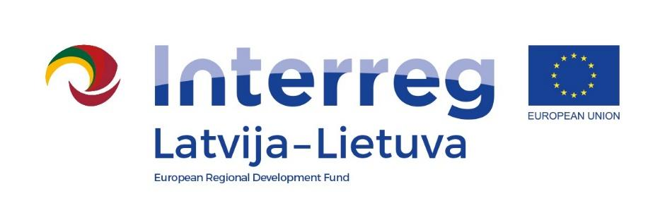

Programme: Interreg V-A Latvia – Lithuania Cross Border Cooperation Programme 2014-2020
Project: LLI-368 “The Creation and Practical Application of Social Inclusion Measures for Persons with Mental Disorders in the Cross Border Region, by using the Experience of Daugavpils and Rokiškis Psychiatric Hospitals”

Project Final Conference

Venue: Daugavpils Psychoneurological Hospital, L. Dārza St. 60/62 (video format)
Date: 09.12.2020.
AGENDA
10:00 – 10:15 | Registration and technicalities
10:15 – 10:30 | Words of welcome  Sarmīte Ķikuste, Member of the Board of Daugavpils Psychoneurological Hospital  Algimantas Liasėdas, Director of Rokiškis Psychiatric Hospital
10:30 – 10:45 | Presentation of the project result by the Lead Partner  Olegs Gorbunovs, Project manager
10:45 – 11:00 | Presentation of the project result by the Project Partner  Artjoms Mahļins, Project manager
11:00 – 11:30 | Psychiatric rehabilitation in Latvia  Dr. Elmārs Tērauds, Head of the Outpatient Center with a hospital “Pardaugava” of Rīga Psychiatry and Narcology Center, Chief Psychiatric Specialist of the Ministry of Health of the Republic of Latvia
11:30 – 12:00 | Inpatient and outpatient psychiatric rehabilitation opportunities in Latvia  Prof. Māris Taube, Head of hospitals of the Outpatient Center "Veldre" of Rīga Psychiatry and Narcology Center, Professor of the Department of Psychiatry and Narcology of Rīga Stradiņš University, President of the Latvian Psychiatric Association
12:00 – 12:15 | Discussion

The conference will be held remotely (using ZOOM).

