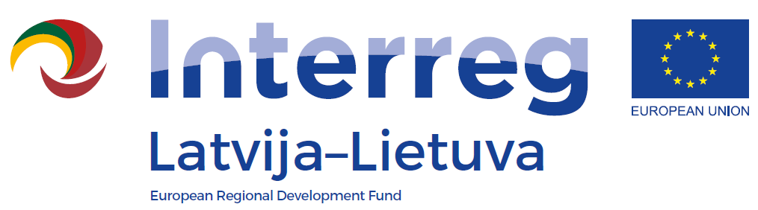

WEBINAR ON PROJECT REPORTING IN EMS WITHIN THE INTERREG V-A LATVIA-LITHUANIA PROGRAMME 2014-2020
3 February 2021

Welcoming and technicalities 9:45 – 10:00

Project reporting in Electronic Monitoring
System (eMS): 10:00 – 12:30
(with one comfort break)
- Preparation of Partner Report
(Questions and answers)

- Preparation of Consolidated Progress Report
(Questions and answers)

- Practical task

