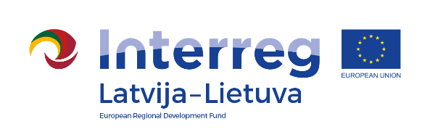
Interreg V-A Latvia–Lithuania Cross Border
Cooperation Programme 2014-2020

Project No. LLI-513 „Empowerment of generations for social integration“ (Power of Generations)

Project opening conference

AGENDA

2021-08-28

Independence Square, Vytauto Didžiojo str. 69, Pakruojis, Lithuania

12.30 – 12.45 | Arrival, registration, welcome coffee and snacks
12.45 – 13.00 | Welcoming words, presentation of the event  Daiva Rutkevičienė, Head of Social Welfare Department of Pakruojis District Municipality Administration, Project coordinator
13.00 – 14.00 | Visiting social workshops, exhibition of art works, handicraft fair, children's play area
14.00 – 15.00 | Overall information about the Project,  Project partners’ presentations – activities within the project, achieved results  Presentation on volunteering and its importance
15.00 – 15.30 | Discussions

Photos and videos will be taken during the event.

Event will be held via zoom also, link https://us02web.zoom.us/j/89337024748

Contact person in Pakruojis District Municipality Administration:
Daiva Rutkevičienė, Project coordinator
Phone +370 421 69074, +370 687 21005, e-mail daiva.rutkeviciene@pakruojis.lt

Project partners:
