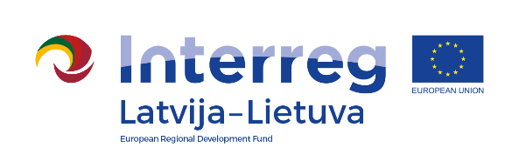
Interreg V-A Latvia–Lithuania Cross Border
Cooperation Programme 2014-2020

Project No. LLI-513 „Empowerment of generations for social integration“ (Power of Generations)

Joint cultural event

AGENDA

2021-08-28

Independence Square, Vytauto Didžiojo str. 69, Pakruojis, Lithuania

10.30 – 11.00 | Arrival, registration, welcome coffee and snacks
11.00 – 11.30 | Getting acquainted with activities:  - social workshops  - exhibition of art works  - Handicraft fair  - children's play area
11.30 – 12.30 | Artistic and cultural activities (songs, dances, games)
12.30 – 14.00 | Work in social workshops, games, art classes (1st part)
14.00 – 15.00 | Lunch
15.00 – 16.00 | Work in social workshops, games, art classes (2nd part)
16.00 – 16.30 | Discussions

Photos and videos will be taken during the event.

Contact person in Pakruojis District Municipality Administration:
Daiva Rutkevičienė, Project coordinator
Phone +370 421 69074, +370 687 21005, e-mail daiva.rutkeviciene@pakruojis.lt

Project partners:
