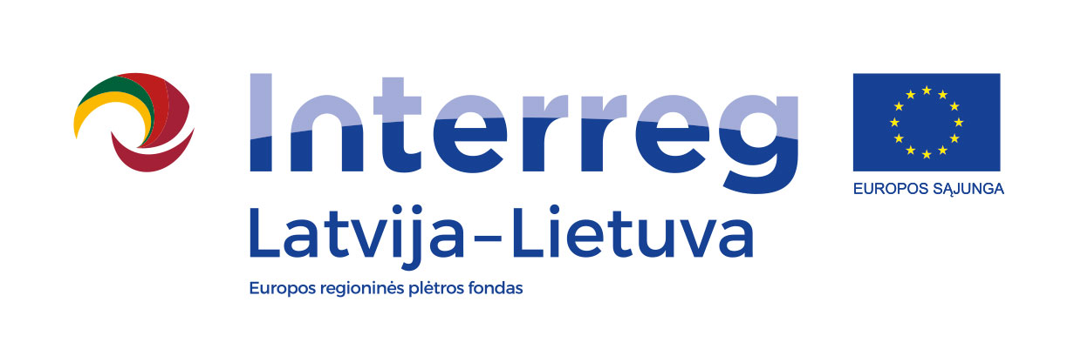
Interreg V-A Latvia–Lithuania Cross Border
Cooperation Programme 2014-2020

Project No. LLI-513 „Empowerment of generations for social integration“ (Power of Generations)

Commemoration of the Day of the grandparents „Let‘s colour autumn“

AGENDA

2021-09-26

Pinne forest of Linksmučiai, Linksmučiai, Naujoji street, Pakruojis district, Lithuania
(Coordinates 55.97347176870354, 23.820981106626533)

10.30 – 11.00 | Arrival, registration, welcome coffee and snacks
11.00 – 12.30 | Greetings  Concert of the children's ensemble "Šypsenėlės"  Character performances, Lithuanian and Latvian dances and games  Team building, tasks and presentations
12.30 – 13.30 | Activities in sectors:  - outdoor games, sport activities, darts  - paper scraping works, art spaces  - constructors robots and love indicator
13.30 – 14.30 | Lunch
14.30 – 15.00 | Thanks to the teams, awards
12.30 – 16.00 | Making temporary tattoos, drawing on faces, trampoline

Photos and videos will be taken during the event.

Contact person in Pakruojis District Municipality Administration:
Daiva Rutkevičienė, Project coordinator
Phone +370 421 69074, +370 687 21005, e-mail daiva.rutkeviciene@pakruojis.lt

Project partners:
