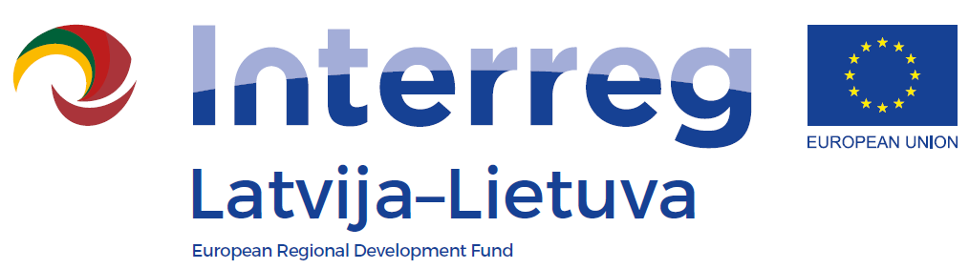

Interreg V-A Latvia – Lithuania Programme 2014-2020

LLI-483 “Use of Unique Geological and Geomorphological Nature Values in the Development of Green Cognitive Tourism“

Conference „Geological heritage“
Agenda
Date: 16th December 2021
Venue: ZOOM (link will be provided)
Language: Lithuanian

9:45 – 10:00 | Registration
10:00 – 10:45 | Life near the ridge: the geological identity of the Žagarė region.  Dr. Jonas Satkūnas, Lithuanian Geological Survey, Nature Research Center
11:00 – 11:45 | Stories of the boulders‘.  Vidas Mikulėnas, Vytautas Puronas, Lithuanian Geological Survey
12:15 – 13:00 | Lunch break
13:00 – 14:00 | Arrangement and adaptation of geological natural heritage objects for visitors in Žagarė Regional Park. Research  Architects Gerda Antanaitytė, Aurimas Baužys, MB Altitudės
14:00 – 15:00 | Landscape Art Park and Open Geological Museum in Žagarė Regional Park. The concept  Architects Gerda Antanaitytė, Aurimas Baužys, MB Altitudės
15:00 – 15.15 | Discussions

