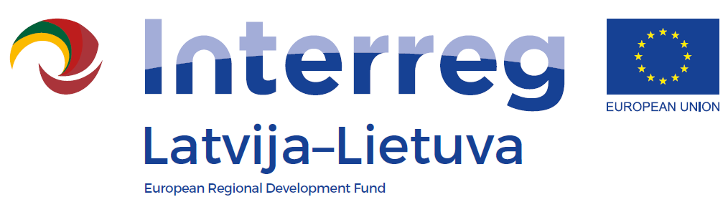

Interreg V-A Latvia – Lithuania Programme 2014-2020

LLI-483 “Use of Unique Geological and Geomorphological Nature Values in the Development of Green Cognitive Tourism“

Training for tourism sector professionals
„Geological heritage: how to understand it and use for tourism“
Agenda
Date: 15th December 2021
Venue: ZOOM (link will be provided)
Language: Lithuanian
9:45 – 10:00 | Registration
10:00 – 11:30 | Disclosure of geological heritage - magic and practice  Dr. Jonas Satkūnas, Lithuanian Geological Survey, Nature Research Center
11:30 – 12:15 | Springs in Lithuania  Dr. Gintarė Slavinskienė, Nature Research Center
12:15 – 13:00 | Lunch break
13:00 – 14:00 | Opportunities to get to know the protected geological heritage in Lithuania  Agnė Jasinavičiūtė, Head of the Landscape Protection Division of the State Service for Protected Areas
14:00 – 15:00 | Use of natural values for tourism in Lithuania and other countries: experience and forecasts  Linas Daubaras, President of the Lithuanian Guides' Union, Lecturer at Kaunas College of Forest and Environmental Engineering
15:00 – 16:00 | Marketing channels and aspects of tourist destinations  Danutė Mažeikaitė, President of the Tourism Marketing Association
15:00 – 15.15 | Discussions

