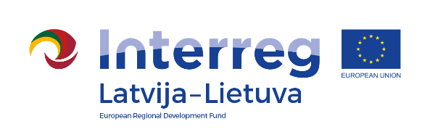
Interreg V-A Latvia–Lithuania Cross Border Cooperation Programme 2014-2020

Project No. LLI-513 „Empowerment of generations for social integration“
(Power of Generations)

Summer camp (D.T2.2.1)

AGENDA

2022-07-01

Linkuva social services center, Parko street 4, Linkuva 83435, Lithuania

8.30 – 9.00 | Arrival, check-in, welcome coffee and snacks.
9.00 – 9.30 | Greetings, Pakruojis Youth Center volunteer concert.  Presentation of camp activities, presentation of volunteers.  Fun program.
9.30 – 12.30 | Lecture "Stress management, improving emotional health" and practical exercises in the sectors:  - psychological consultations and activities;  - physical activity;  - healthy eating activities.
12.30 – 13.30 | Lunch
13.30 – 16.00 | Lecture "Stress management, improving emotional health" and practical exercises in the sectors:  - sound therapy sessions;  - art therapy classes.
16.00 – 16.30 | Discussions, camp closure, farewell coffee and snacks

Photos and videos will be taken during the event.

Contact person in Pakruojis District Municipality Administration:
Daiva Rutkevičienė, Project coordinator
Phone +370 421 69074, +370 687 21005, e-mail daiva.rutkeviciene@pakruojis.lt

Project partners:
