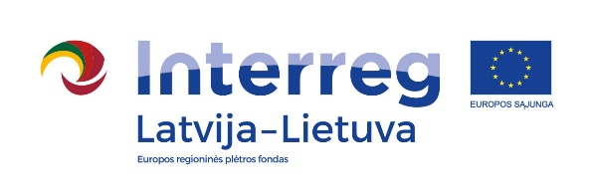
2014–2020 m. Interreg V-A Latvia- Lithuania Cross-Border Cooperation Programme

Project No. LLI-513
“Empowerment of Generations for Social Integration“) (Power of Generations)

Seminar "Reducing the Consequences of the Aging Process by Involving Individuals in Volunteering"

Programme
19-20th May 2022

Green Park Hotel, Minijos st.119, Klaipėda, Lithuania

19th May (Thursday)
9.30-10.00 | Registration. Coffee/tea
10.00-12.00 | Seminar "Reducing the Consequences of the Aging Process by Involving Individuals in Volunteering"
12.00 – 12.30 | Lunch
12.30 – 14.30 | Seminar "Reducing the Consequences of the Aging Process by Involving Individuals in Volunteering"
14.30 – 14.40 | Coffee/tea break
14.40 – 17.40 | Lecture "The Involvement of the Elderly in the Voluntary Activities in Klaipeda District"  Address: Klaipėda University, Herkaus Manto st. 90, Klaipėda.
17.40-18.20 | Dinner
Filming and photography will take place during the event.
Project partners:
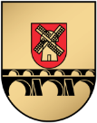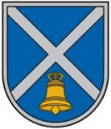

2014–2020 m. Interreg V-A Latvia- Lithuania Cross-Border Cooperation Programme

Project No. LLI-513
“Empowerment of Generations for Social Integration“) (Power of Generations)

Seminar "Reducing the Consequences of the Aging Process by Involving Individuals in Volunteering"

20th May (Friday)
8.00-9.00 | Breakfast. Registration, Coffee/tea. Address: Green Park Hotel, Minijos st.119, Klaipėda. Departure for the social care institution
9.00-11.00 | Study visit. Sharing experience on the implementation of the project LLI-1 “Joint Competence Center for Smart Elderly Care Social Services Development“ Address: Klaipėda City Care Home. Žalgirio st. 3A, Klaipėda
11.00-12.30 | Study visit to Klaipėda Social Services Center "Danė". Address: Kretingos st. 44, Klaipėda
12.30 – 13.30 | Lunch
14.00 – 15.30 | Meeting with Kretinga seniors - volunteers Address: Vilniaus st. 2a, Kretinga, Klaipėda District
15.30– 15.45 | Coffee/tea break
15.45 - 16.00 | Discussion on the seminar "Reducing the Consequences of the Aging Process by Involving Individuals in Volunteering" and the best practices of the social institutions visited in Klaipėda  Address: Vilniaus st. 2a, Kretinga, Klaipėda District
Filming and photography will take place during the event.

Contact person in Pakruojis District Municipality Administration:
Daiva Rutkevičienė, project coordinator
Tel. +370 421 69074, +370 687 21005, e-mail daiva.rutkeviciene@pakruojis.lt

Project partners:

