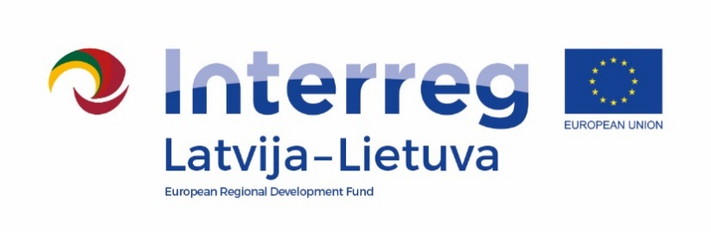
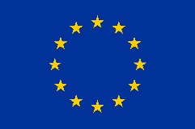

Interreg V-A Latvia – Lithuania Programme 2014-2020

The safe environment for pupils and teachers – the basis for quality education (Safe School, LLI-506)

Cycling competitions for safe driving
Iecava, Bauska Municipality Government
2022-06-11
Agenda
Venue: Iecava, Bauska Municipality

10:30 – 11:00 | Arrival and registration  Skolas street 37,.Iecava, Bauska Municipality
11:00- 14:00 | Bicycle driving skills competitions, 4 work stations  Skolas street 37, Skolas street, Sporta street 4, Iecava
14:00 – 14:30 | Awarding, closing of the event

Filming and photography will take place during the event.
Contact person in Bauska Municipality Government:
Ineta Bramane, project coordinator
Phone +371 22006871, e-mail ineta.bramane@iecava.lv

