Nr. LLI-539 „Amatniecība kā tūrisma produkts bez robežām”
(Craftsmanship as Tourism Product without Borders/Tour de Crafts”).
Creative workshops for crafsman /artists (Ceramics)

Dates: 1-3 of June, 2022
Place: Preili, Raiņa bulvāris 19

1 day (01.06)  10.30 - 11.00 11.00 – 12.00 Registration Introduction, Preili manor complex and Preili Castle  12.00 – 13.00 Lunch break  13.00 – 13.30 Visit to the pottery museum  13.30 – 15.00 Pottery master class and manufacture of products  15.00 – 15.30 Coffe break (Pampūkas) https://www.facebook.com/pampukas  15.30 – 17.00 17.15 Porcelain master class and manufacture of products (https://www.facebook.com/PieceOfTouch) Accommodation, dinner (Dzeņu mājas https://laba-sajuta.mozello.lv/) It is possible to apply for a sauna  2.day (02.06.)  09.00 – 9.30 Breakfest  9.30 – 12.00 Pottery master class and manufacture of products (Jašas podi http://www.jasaspodi.com/)  12.30 – 13.30 Lunch break  13.30 – 14.30 Visit to Rainis Museum Jasmuiža (https://memorialiemuzeji.lv/museums/raina-muzejs-jasmuiza/)  14.30 – 15.30 15.30 – 16.00 16.30 Visit public center Aizkalne/ Guna Egle - dream catcher master class Coffe break Free time. Dinner.  3 day (03.06)  9.00 – 9.30 Breakfest  9.30 – 10.00 Going to the Aglona Center for the Creative Industries  10.15 – 12.30 Introduction with Center for the Creative Industries, manufacture of products  12.30 – 13.30 Lunch break  13.30 – 15.00 Visit Christ the King Mountain https:// agkk.lv/ | 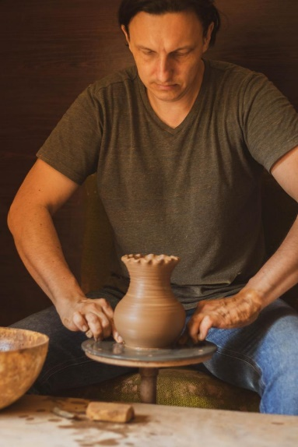  Potter Raivo Andresons  Potter Sintija Logina  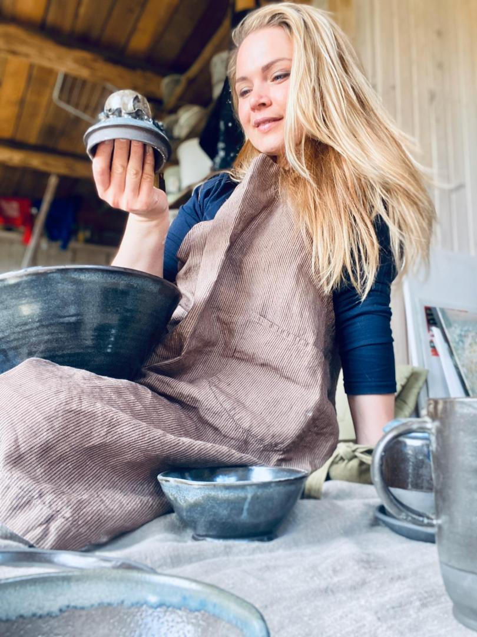  Potter Kristīne Nicmane  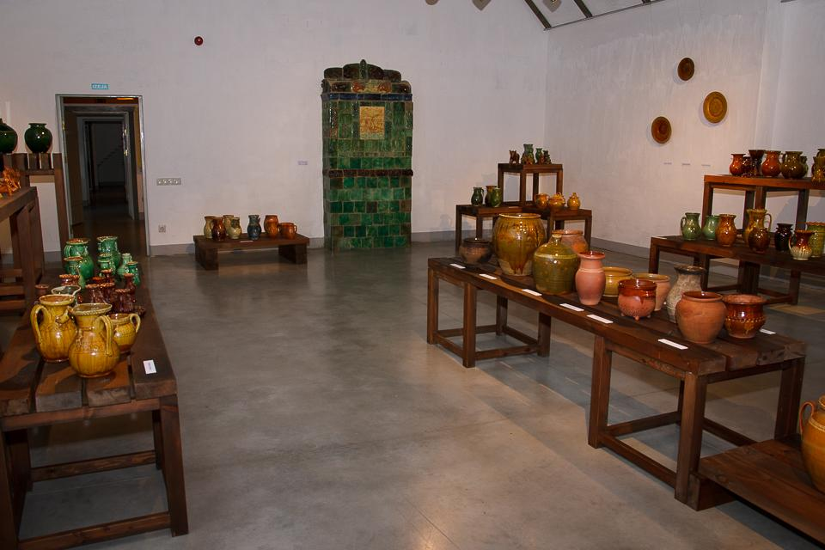  Rainis Museum Jasmuiza  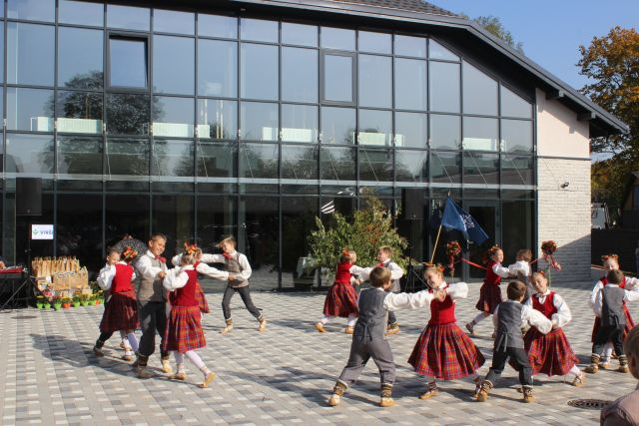  Aglona Center for the Creative Industries

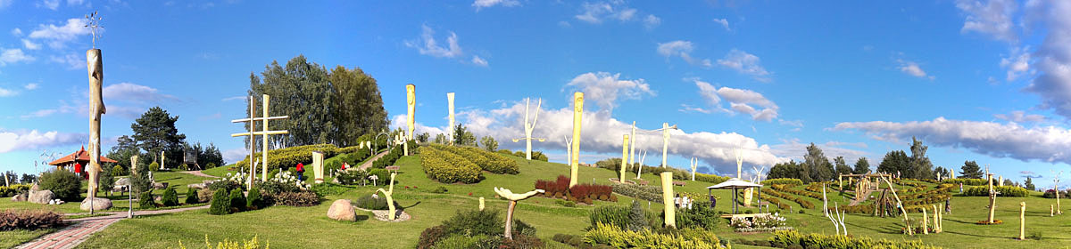
Christ the King Mountain

