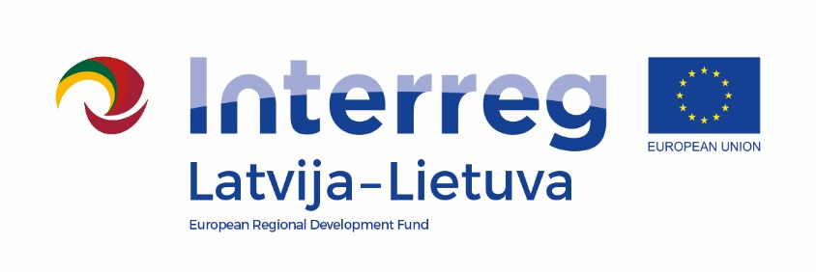
Interreg V-A Latvijos – Lietuvos Programa 2014 -2020
Project
“CRAFTSMANSHIP AS TOURISM PRODUCTS WITHOUT BORDERS”
/ Tour de Craft, LLI -539 /

Steering Committee meeting
9 of June 2022
Anyksciai art incubator- art studio
J.Biliūno g.53, Anykščiai

AGENDA

10.30 - 11.00 | Registration of participants  Exposition of project creative workshops results
11.00 – 12.45 | Welcome words  Representative of Anykščiai district municipality  Kristine Smagare, project manager  Meeting participants of the project. Participation in the opening activities of Art fair
12.45 - 13.00 | Coffee break
13.00 – 15.00 | Presentations of project Implementation:  - Goals and achievements (LP)  - Project activities in partners' sites (All partners)  - Sustainable value and impact of the project (LP)
15.00 - 16.00 | Lunch
16.00 – 17.00 | Discussions, networking, possibilities of cooperation

* Photos will be taken during the event and this material will be used for project communication

