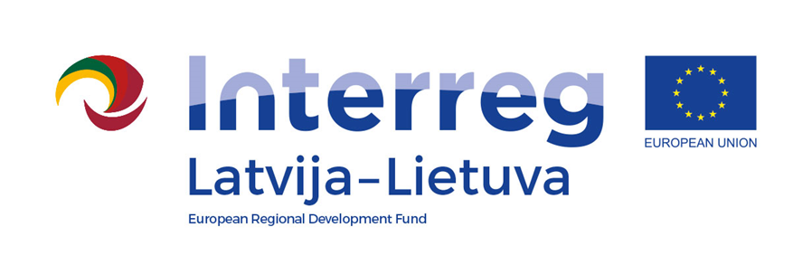
Interreg V-A Latvia–Lithuania Cross Border Cooperation Programme 2014-2020

Project No. LLI-513 “Empowerment of Generations for Social Integration“
(Power of Generations)

Seminar "Volunteering and its impact on the socialization of young people"

Training activities and study visits for volunteers (Activity T.1.2.)

Agenda
21st and 22nd June, 2022

Cafe “Žarija“, Ežero st. 2, Velžių village, Radviliškis District, Lithuania

First day, 21th June (Tuesday)
9.30–10.00 | Registration. Coffee/tea
10.00–-12.00 | Seminar "Volunteering and its impact on the socialization of young people"
12.00 – 12.30 | Lunch
12.30 – 14.30 | Seminar "Volunteering and its impact on the socialization of young people"
14.30 – 14.40 | Coffee/tea break
14.40 – 16.40 | Seminar "Volunteering and its impact on the socialization of young people"
16.40 – 17.20 | Dinner
Filming and photography will take place during the event.
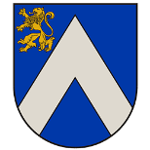
Project partners:
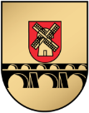
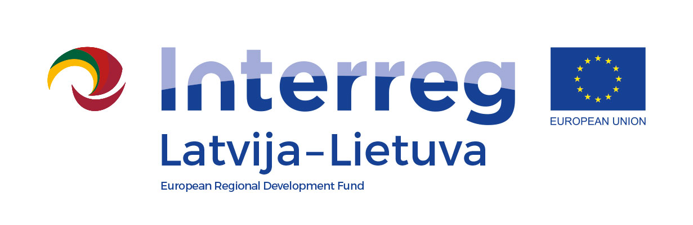
Interreg V-A Latvia–Lithuania Cross Border Cooperation Programme 2014-2020

Project No. LLI-513 “Empowerment of Generations for Social Integration“
(Power of Generations)

Seminar "Volunteering and its impact on the socialization of young people"

Training activities and study visits for volunteers (Activity T.1.2.)

Second day, 22th June (Wednesday)
8.00 – 9.00 | Breakfast. Registration, Coffee/tea. Address: Cafe „Žarija“, Ežero st. 2, Velžių village, Radviliškis District. Departure for the Youth Centre
9.10 – 10.00 | Study visit at Open Youth Centre “Jaunimo erdvė“ of Radviliškis District Municipality Education and Sport Services Centre Adult and Youth Non-formal Education Department. Address: Šeduva Laisvės sq. 29, Šeduva
10.30 – 11.20 | Study visit at Open Youth Centre “Jaunimo erdvė“ of Radviliškis District Municipality Education and Sport Services Centre Adult and Youth Non-formal Education Department. Adresas: Radvilų st. 17 , Radviliškis
11.35 – 12.35 | Lunch
13.30 – 14.20 | Study visit at Panevėžys Open Youth Centre. Address: Ramygalos st.18, Panevėžys
15.15 – 15.30 | Coffee/tea break
15.30 – 16.00 | Discussion and evaluation of the seminar "Volunteering and its impact on the socialization of young people" at Pakruojis Youth Centre. Address: L. Giros st. 4, Pakruojis
Filming and photography will take place during the event.

Contact person in Pakruojis District Municipality Administration:
Daiva Rutkevičienė, project coordinator
Tel. +370 421 69074, +370 687 21005, e-mail daiva.rutkeviciene@pakruojis.lt

Project partners:

