Interreg V-A Latvia–Lithuania Cross Border Cooperation Programme 2014-2020

Project No. LLI-513 “Empowerment of Generations for Social Integration“
(Power of Generations)

Seminar "Prejudices and stereotypes, anyone aged, including the young, specifics of generations and how to understand it, conflicts between generations and how to avoid them"

Training activities and study visits for volunteers (Activity T.1.2.)

Agenda
12-13th July 2022

Iecava parish, Bauska municipality, LV -3913, Latvia

First day, 12th July (Tuesday) SEMINAR
8.45- 9.30 | Arrival, registration, coffe
9.30-11.30 | - Prejudices and stereotypes, everyone grows old, or what age is - an advantage or a tragic fate. Young people will grow old too  - Age stage options and choices at each age stage
11.30-11.45 | Pause
11.45 – 14.00 | - Social roles at each age stage. How to be socially active and integrate into society in a healthy way at every age  - Generational conflicts in different areas - between roles, between choices and opportunities
14.00 – 15.00 | LUNCH
15.00 – 17.00 | - Creating compromises between generations, preventive prevention of conflicts, how to avoid them
17.00 – 17.45 | Disscussions on seminar, conclusions
18.30-19.30 | Dinner
Filming and photography will take place during the event.

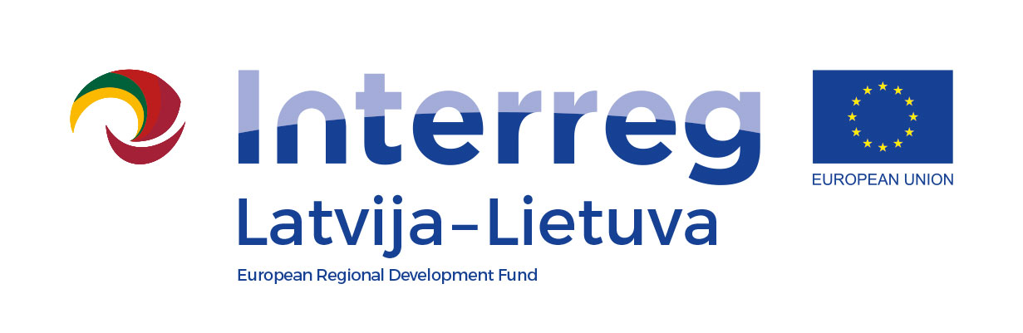
Interreg V-A Latvia–Lithuania Cross Border Cooperation Programme 2014-2020

Project No. LLI-513 “Empowerment of Generations for Social Integration“
(Power of Generations)

Seminar " Prejudices and stereotypes, anyone aged, including the young, specifics of generations and how to understand it, conflicts between generations and how to avoid them "

Training activities and study visit for volunteers (Activity T.1.2.)

Second day, 13th July (Wednesday) STUDY VISIT
8.00-8.45 | Breakfast. Registration (at seminar place). Departure to Social Care Centre
9.30-11.00 | Study visit at State Social Care Center "Iecava" Smiltaiņi, Iecava parish, Bauska municipality, LV-3913
11.00-11.15 | Departure to /arrival to Day centre Iecavnīca Grafa square 1, Iecava, Bauska municipality
11.15- 12.30 | Communication about volunteering, actual activities – volunteering with Ukrainians
12.30– 13.00 | Coffee/tea break  Iecava Day Centre, Grafa square 1, Iecava, Bauska municplaity
13.00 – 15.00 | Volunteering in municipality. Visit to Municipal Social Service Iecava division. Disccusions and closing of stydy visit  Dzirnavu street 1. Iecava, Bauska municipality.
Filming and photography will take place during the event.

Contact person in Bauska Municipality Government:
Ineta Bramane, project coordinator
Phone +371 22006871, e-mail ineta.bramane@iecava.lv

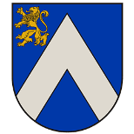
Project partners:

