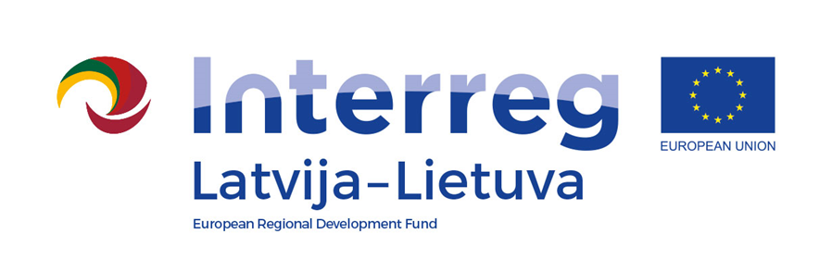
Interreg V-A Latvia–Lithuania Cross Border Cooperation Programme 2014-2020

Project No. LLI-513 “Empowerment of Generations for Social Integration“
(Power of Generations)

Summer school (camp) in Iecava

Implementation of social integration measures (Activity T 2.2., Deliverable D.T. 2.2.1)

.1.2.)

Agenda
21 July 2022

„Labirinti“, Iecava parish, Bauska municipality, LV -3913, Latvia

21th July (Thursday)
9.30 – 10.00 | Arrival, registration, division of participants into three groups  Opening of summer camp  Ineta Bramane, Sigma Strautmale
10.00 – 11.00 | Dance performance and joint musical dance lesson for all participants  together with the dance group "Kamenes"
11.15 – 12.00 | Activities for everyone, getting to know the owner and the place "Labyrinth".  Jānis Pastars  For building emotional balance - breathing "through the fingers", big turns, relaxation of vision and positive memory training, stress management and psycho-emotional well-being - positive thinking.  Ginta Zaumane
12.00 – 13.00 | LUNCH
Work on groups
13.00 – 15.30 | 1. Know yourself by drawing  2. Agility competition between groups. Jenga and dominoes (big outdoor games)  3. Creating a botanical barelief - working with natural materials, clay, plaster, acrylic paints, making a wind chime - working with clay blanks, acrylic paints, linen cord.
15.30 – 16.00 | Tea, coffe
16.00-17.00 | Closing of the summer school, discussions and conclusions
.
Filming and photography will take place during the event.

Contact person in Bauska Municipality Government:
Ineta Bramane, project coordinator
Phone +371 22006871, e-mail ineta.bramane@iecava.lv

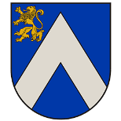
Project partners:
