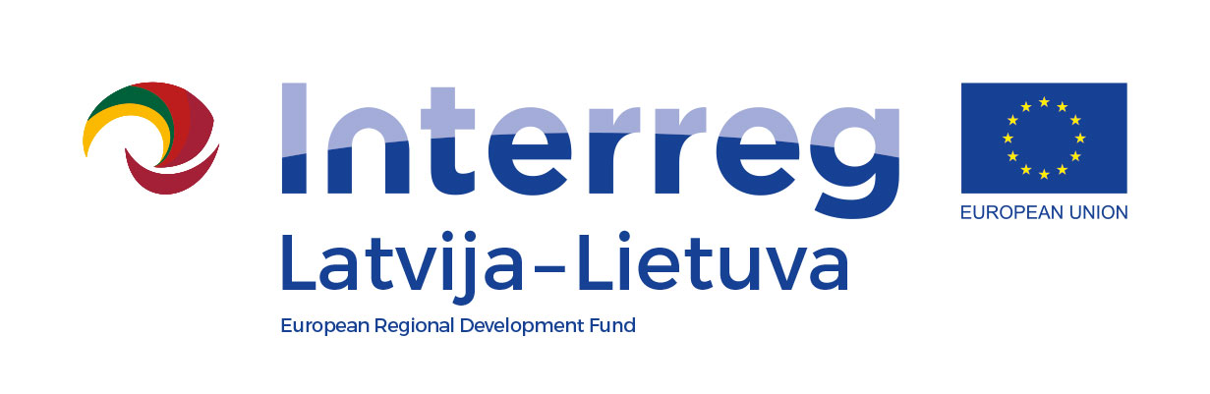
Interreg V-A Latvia–Lithuania Cross Border Cooperation Programme 2014-2020

Project No. LLI-513 “Empowerment of generations for social integration“
(Power of Generations)

Seminar "Intergenerational conflicts, their causes, consequences,
work with them, and prevention, possible prevention or how to avoid conflicts,
is prevention possible at all "

Training activities and study visit for specialists
(Activity T.1.1.)

Agenda

04-05, August, 2022
Līčupes, Iecava parish, Bauska municipality, LV-3913, Latvia

First day, 4th August, 2022 (Thursday)
8.45 - 9.30 | Arrival, registration, coffee
9.30 -11.30 | - Characterization of the characteristics of people (generations) of different ages  - Social, emotional, sexual, political and economic factors affecting relationships between people of different generations in Latvia and Lithuania
11.30 -11.45 | Pause
11.45 – 14.00 | - Causes of conflicts in the modern family and family  - Consequences of generational conflicts for the individual, family, clan, community (municipality, local society) and the country
14.00 – 15.00 | LUNCH
15.00 – 17.00 | - Counselling of social work clients on prevention of destructive behaviour in cases of conflicts  - Ways and methods of constructive resolution of generational conflicts
17.00 – 17.45 | Discussions on seminar, conclusions
18.30-19.30 | Dinner
Filming and photography will take place during the event.

Interreg V-A Latvia–Lithuania Cross Border Cooperation Programme 2014-2020

Project No. LLI-513 “Empowerment of generations for social integration“
(Power of Generations)

Seminar " Intergenerational conflicts, their causes, consequences,
work with them, and prevention, possible prevention or how to avoid conflicts,
is prevention possible at all "

Training activities and study visit for specialists
(Activity T.1.1.)

Second day, 5th August 2022 (Friday)
9.00 - 9.40 | Breakfast.
9.50 – 11.00 | Departure to Ogre - arrival to Ogre Social Service Department  Upes prospect 16, Ogre
11.00 -11.25 | Introduction with head of Service and workers.  Presentation of Ogre Social service
11.30 - 12.00 | Visit in Ogre Social Service, introduction
12.10 - 12.50 | Visit in Day Centre „Saime", experience exchange  Parka street 1, Ogre
13.00 - 13.40 | Tea, coffee
13.40 - 14.30 | Visiting of specialized workshops for persons with mental disorders
14.30 - 15.30 | Discussion on the seminar. Conclusions and comparisons. Summary of study visit and
Filming and photography will take place during the event.

Project partners

Contact person in Bauska Municipality Government:
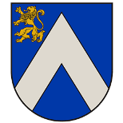
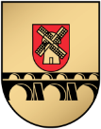
Sigma Strautmale, social specialist
Phone +37126354768 , e-mail sigma.strautmale@iecava.lv

