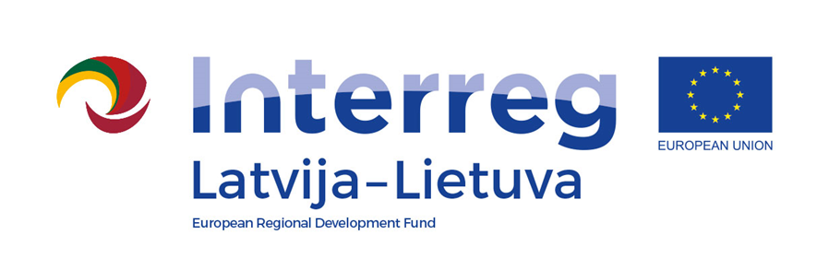
Interreg V-A Latvia–Lithuania Cross Border Cooperation Programme 2014-2020

Project No. LLI-513 “Empowerment of Generations for Social Integration“
(Power of Generations)

Seminar "Psychology of the elderly. Engaging volunteers in social work"

Training activities and study visit for specialists (Activity T.1.1.)

Agenda
15-16 th September 2022

Hotel, „Idilė“, Energetikų St.5, Visaginas, Utena District, Lithuania

First day, 15 th September (Thursday)
10.30-11.00 | Registration. Coffee/tea Address: Energetikų St.5, Visaginas, Utena District, Lithuania
11.00-12.30 | Seminar "Psychology of the elderly. Engaging volunteers in social work"
12.30-13.00 | Lunch
13.00 – 14.30 | Seminar "Psychology of the elderly. Engaging volunteers in social work"
14.30 – 14.40 | Coffee/tea break
14.40 – 17.00 | Seminar "Psychology of the elderly. Engaging volunteers in social work"
17.00-17.20 | Dinner
17.20-18.00 | The discussion about seminar "Psychology of the elderly. Engaging volunteers in social work"
Filming and photography will take place during the event.

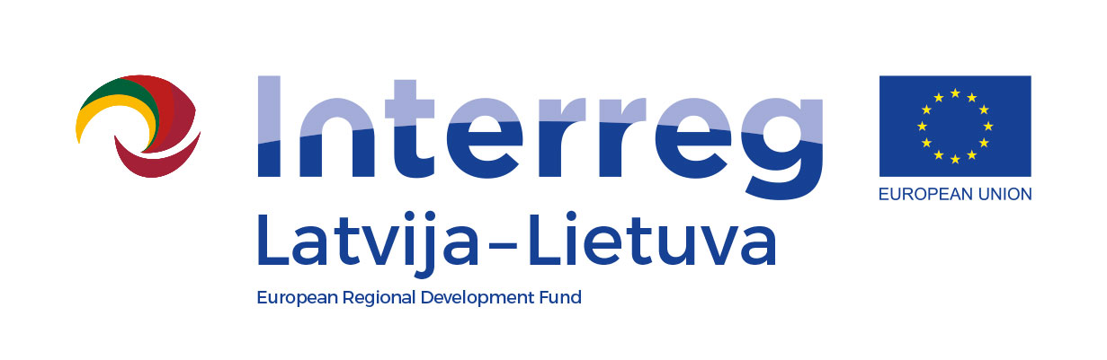
Interreg V-A Latvia–Lithuania Cross Border Cooperation Programme 2014-2020

Project No. LLI-513 “Empowerment of Generations for Social Integration“
(Power of Generations)

Seminar "Psychology of the elderly. Engaging volunteers in social work"

Training activities and study visit for specialists (Activity T.1.1.)

Second day, 16 th September (Friday)
8.00-8.30 | Breakfast. Registration, Coffee/tea. Hotel, „Idilė“, Address: Energetikų St.5, Visaginas, Utena District, Lithuania. Departure for the social care institution
9.40-11.00 | Study visit. Public Institution „Angelų pieva“ Address: Užpalių St. 86, Utena
12.50-14.00 | Lunch Café „Kepinių namai“. Address: Josvainių St. 2, Kėdainiai
14.10 – 15.10 | Study visit Kėdainiai Family Support Centre. Address: Vydūno St. 6, Kėdainiai
16.30 – 17.00 | Study visit. Linkuva Social Services Centre Care Home “Atokvėpis" Address: Parko St. 4, Linkuva, Pakruojis District
17.00– 17.20 | Coffee/tea break. Address: Parko St. 4, Linkuva, Pakruojis District. We‘re going home.
Filming and photography will take place during the event.

Contact person in Pakruojis District Municipality Administration:
Daiva Rutkevičienė, project coordinator
Tel. +370 421 69074, +370 687 21005, e-mail daiva.rutkeviciene@pakruojis.lt

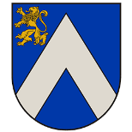
Project partners:
