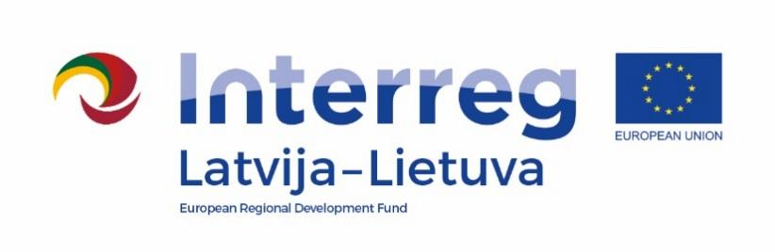

2014–2020 m. Interreg V-A Latvia- Lithuania Cross-Border Cooperation Programme

Project No. LLI-506 „The safe environment for pupils and teachers – the basis for quality education“ (Safe school)

D.M.3.7. Final meeting in Pakruojis

AGENDA

2022-10-18

The house of the Pakruojis firemen's society,
Laisvės square 10, Pakruojis LT-83157 Pakruojis, Lithuania

14:00 – 14:15 | Registration
14:15 – 14:35 | Presentation about the project progress, reached results (ZPR)
14:35 – 15:35 | Presentation about the project progress, reached results (each partner)
15:35 – 16:00 | Discussions and closing of the event

Photos and videos may be taken at this event for publicity purposes.

Contact person:
Lina Mikolaitytė, Project manager in Pakruojis district municipality administration
Phone +370 652 72032, e-mail lina.mikolaityte@pakruojis.lt

