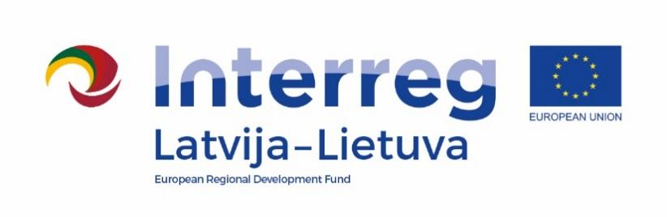

2014–2020 m. Interreg V-A Latvia- Lithuania Cross-Border Cooperation Programme

Project No. LLI-506 „The safe environment for pupils and teachers – the basis for quality education“ (Safe school)

D.T1.1.3 Good Practice Exchanges for Teachers in Lithuania

AGENDA

2022-10-18

First part: Pakruojis “Žemyna” progymnasium, P. Mašioto street 45, LT-83135 Pakruojis, Lithuania
09:30 – 10:00 | Registration, tea/coffee
10:00 – 10:10 | Welcome words (Project manager in PP_4 Lina Mikolaitytė)
10:10 – 10:30 | Presentation of Pakruojis „Žemyna“ progymnasium, implemented activities during the project  (representors of Pakruojis „Žemyna“ progymnasium)
10:30 – 10:50 | Ensuring emotional safety in Pakruojis „Žemyna“ progymnasium  (representors of Pakruojis „Žemyna“ progymnasium)
10:50 – 11:10 | Presentation of Lygumai basic school  (representors of Lygumai basic school)
11:10 – 12:00 | Visiting Pakruojis “Žemyna” progymnasium

Second part: Pakruojis Lygumai basic school, Mokyklos street 7, LT-83306 Lygumai, Pakruojis district, Lithuania
12:00 – 12:20 | Trip from Pakruojis to Lygumai (each partner with its own transport)
12:20 – 13:10 | Visiting Lygumai basic school
13:10 – 13:40 | Lunch

Photos and videos may be taken at this event for publicity purposes.

Contact person:
Lina Mikolaitytė, Project manager in Pakruojis district municipality administration
Phone +370 652 72032, e-mail lina.mikolaityte@pakruojis.lt

