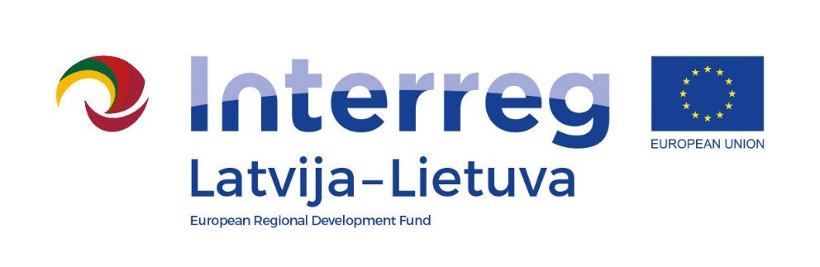

Interreg V-A Latvia–Lithuania Cross Border
Cooperation Programme 2014-2020

Project No. LLI-513 „Empowerment of generations for social integration“ (Power of Generations)

Joint cultural event „All together!“
Activity T.2.2.

AGENDA

2023-04-22
Iecava Culture House, Rigas street 18, Iecava, Bauska municipality

10.30 – 11.00 | Arrival, registration
11.00 – 12.30 | Opening and greetings  Concert of the Lithuanian and Latvian collectives – dances, songs and games
12.30 - 13.00 | Cofee/tea table with snacks
13.15 – 15.30 | Activities in sectors:  - creative workshops,  - intelectual games,  - physical activities.
15.30 - 16.00 | Summary and closing of an event

Photos and videos will be taken during the event.

Contact person in Bauska Municipality Government:
Ineta Bramane, project coordinator
Phone +371 22006871, e-mail ineta.bramane@iecava.lv

Project partners:
