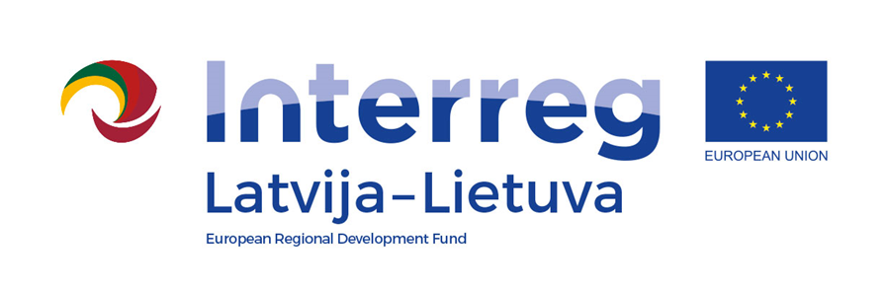
Interreg V-A Latvia–Lithuania Cross Border Cooperation Programme 2014-2020

Project No. LLI-524 “Booster for ReStart in Pakruojis and Iecava municipalities”
(Booster for ReStart)

A.C.1. Public Event(s)
D.C1.1. Organized conference

Closing conference

D.T2.4.1

AGENDA

2023-06-27

The house of the Pakruojis firemen's society,
Laisvės square 10, Pakruojis LT-83157 Pakruojis, Lithuania

15:55 – 16:00 | Registration
16:00 – 16:30 | Project partners’ presentations – activities within the project, achieved results
16:30 – 17:30 | Work in groups “What can we do for better future?”  (preparation of ideas how develop social sport infrastructure and methods of fighting a sedentary lifestyle, in improving socio-economic condition by adapting public infrastructure to the local community needs, also strengthen cross border cooperation, foster improvement of accessibility and efficiency of the physical activity level in the regions)
17:30 – 18:00 | Presentation of prepared ideas, discussions

Videos and photos will be taken for promotional purposes.

Contact person in Pakruojis District Municipality Administration:
Lina Mikolaitytė, Project manager,
Phone +370 652 72032, e-mail lina.mikolaityte@pakruojis.lt

