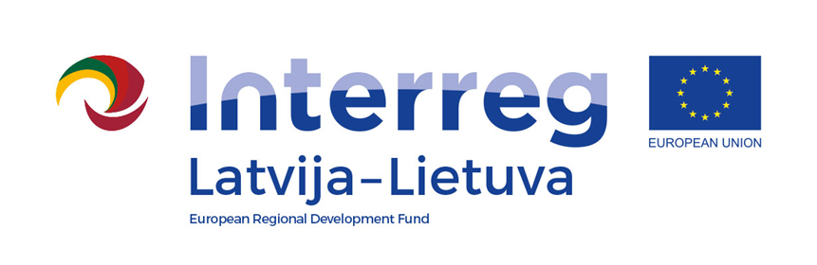
Interreg V-A Latvia–Lithuania Cross Border
Cooperation Programme 2014-2020

Project No. LLI-513 „Empowerment of generations for social integration“)
(Power of Generations)

D.M.2.1. Organized partners meetings

Project Partners’ meeting

D.T2.4.1

AGENDA

2023-06-29

Place: Skolas iela 4-40, Iecava, Bauska municipality, LV-3913

10:30 | Arrival
10:30 – 12:00 | Discussions on approved changes, left publicity activities, information needed to upload/change in the Programme webpage www.latlit.eu , review of results quality assessment, preparation of the final report, discussions and plans of project durability  Lina Mikolaitytė,  project manager, Pakruojis District Municipality Administration  Daiva Rutkevičienė,  project coordinator, Pakruojis District Municipality Administration  Ineta Bramane,  project manager, Bauska Municipality Government
12:00 – 13:00 | Lunch (not included)
13:00 – 14:00 | Discussions on approved changes, left publicity activities, information needed to upload/change in the Programme webpage www.latlit.eu , review of results quality assessment, preparation of the final report, discussions and plans of project durability  (prolongation)

For more information please contact
Ineta Bramane, +371 22006871, ineta.bramane@bauskasnovads.lv

