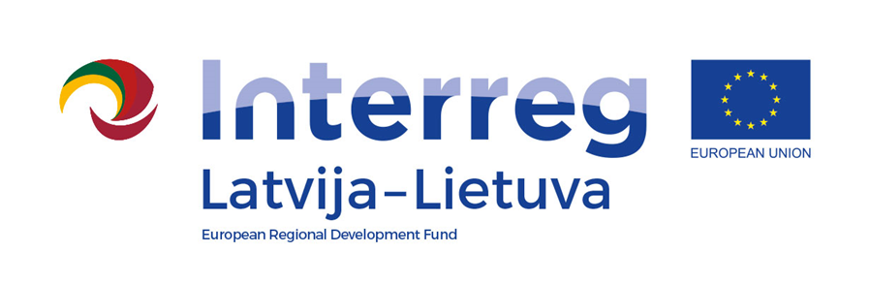
Interreg V-A Latvia–Lithuania Cross Border Cooperation Programme 2014-2020

Project No. LLI-524 “Booster for ReStart in Pakruojis and Iecava municipalities”
(Booster for ReStart)

D.T1.1.1 The experience sharing visits for specialists

D.T2.4.1

AGENDA

16.06.2023.

Place: Iecava town, Bauska municipality, Latvia

11:00 – 11:05 | Arrival, registration
11:05 – 11:15 | Start of the event, welcome speech of project manager I.Bramane and head of Iecava association administration N.Vāvers
11:15 – 14:45 | Visiting of different sport infrastructure objects and objects developed on deprived territories of Iecava
14:45 - 15:00 | Results, conclusions, closing of the event

Videos and photos will be taken during the event for promotional purposes.
Depending on the number of participants, the duration of the event may change.

Contact person in Bauska Municipality Administration:
Ineta Bramane, Project manager,
Phone +371 22006871, e-mail ineta.bramane@bauskasnovads.lv

