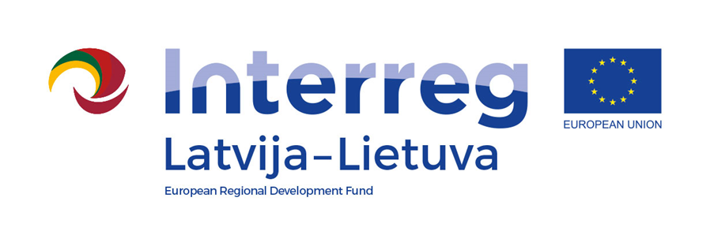
Interreg V-A Latvia–Lithuania Cross Border Cooperation Programme 2014-2020

Project No. LLI-524 “Booster for ReStart in Pakruojis and Iecava municipalities”
(Booster for ReStart)

A.T1.1. The experience sharing visits for specialists
D.T1.1.1. Specialists participated in the experience sharing visits

The experience sharing visit for specialists in Bauska town

D.T2.4.1

AGENDA

2023-06-28

Arrival: Bauska Municipality Administration, Uzvaras street 1, Bauska, Latvia

10:00 | Arrival at Bauska Municipality Administration
10:10 – 14:30 | Visiting sports/public/leisure infrastructure in Bauska:  - Bauska town stadium;  - Sports hall of Children and Youth Sports School of the Bauska Municipality;  - Bauska Secondary school Nr.2. sport yard;  - Multifunctional sports and recreation centre “Bauska swimming pool" of the Children and Youth Sports School of the Bauska Municipality;  - Planned recreation/leisure territory next to pool territory;  - Renovated Memele street and walking trail;  - Developed leisure activities and picnic place on Dambja street;  - Leisure and recreation place with a fountain on Īslīces street.
14:30 – 15:00 | Discussions, trip home

Videos and photos will be taken during the visit for promotional purposes.

Contact person in Bauska Municipality Administration:
Ineta Bramane, Senior Project manager,
Phone +371 22006871, e-mail ineta.bramane@bauskasnovads.lv

