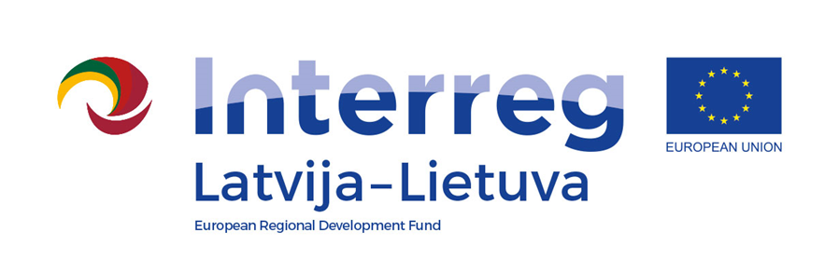
Interreg V-A Latvia–Lithuania Cross Border Cooperation Programme 2014-2020

Project No. LLI-524 “Booster for ReStart in Pakruojis and Iecava municipalities”
(Booster for ReStart)

A.T1.1. The experience sharing visits for specialists
D.T1.1.1. Specialists participated in the experience sharing visits

The experience sharing visit for specialists in Kelmė district

D.T2.4.1

AGENDA

2023-06-27

Arrival: Kelmė sport center, J. Janonio street 11, LT-86122 Kelmė, Lithuania

10:00 | Arrival at Kelmė sport center
10:00 – 13:00 | Visiting sports/public/leisure infrastructure in Kelmė:  Kelmė sport center  Kelmė dis cgolf park  Kelmė tennis corts  Kelmė stadium  Kelmė public park  Kelmė Jono Graičiūno gymnasium
13:00 – 13:30 | Trip to Tytuvenai
13:30 – 15:30 | Visiting sports, leisure infrastructure and public spaces in Tytuvėnai

Videos and photos will be taken during the visit for promotional purposes.

Contact person in Pakruojis District Municipality Administration:
Lina Mikolaitytė, Project manager,
Phone +370 652 72032, e-mail lina.mikolaityte@pakruojis.lt

