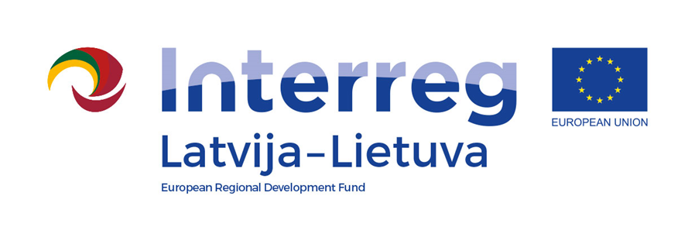
Interreg V-A Latvia–Lithuania Cross Border Cooperation Programme 2014-2020

Project No. LLI-524 “Booster for ReStart in Pakruojis and Iecava municipalities”
(Booster for ReStart)

A.T1.1. The experience sharing visits for specialists
D.T1.1.1. Specialists participated in the experience sharing visits

D.T2.4.1

AGENDA

2023-06-19

Arrival: Pakruojis city stadium, Bagdoniskio street 2, LT-83128, Pakruojis, Lithuania

11:50 – 12:00 | Arrival, registration
12:00 – 12:10 | Participating in the Joint sport competition event opening
12:10 – 15:30 | Visiting sports/public/leisure infrastructure in Pakruojis:
12:10 – 12:20 | Newly installed skateboard/roller/BMX skatepark
12:20 – 12:50 | Pakruojis “Atžalynas” gymnasium stadium, sport hall
12:50 – 13:30 | Pakruojis J. Pakalnis art school and Pakruojis open youth center
13:30 – 14:00 | Unity square, Pakruojis market, Pakruojis firemen's building
14:00 – 15:30 | Synagogue, Kruojas river island, park, disc golf park
15:30 – 16:00 | Participating in the Joint sport competition event awards, closing of the event

Videos and photos will be taken during the event for promotional purposes.

Contact person in Pakruojis District Municipality Administration:
Lina Mikolaitytė, Project manager,
Phone +370 652 72032, e-mail lina.mikolaityte@pakruojis.lt

